Contents

FLOATING POINT BINARY REPRESENTATION 2

CREATING THE IEEE REPRESENTATION 29

POSITIVE AND NEGATIVE INFINITY 37

CONVERTING DECIMAL FRACTIONS TO BINARY REALS 40

FLOATING POINT UNIT 46

FLOATING-POINT EXCEPTIONS 56

FLOATING-POINT INSTRUCTION SET 59

FLOATING POINT ARITHEMETIC 68

COMPARING FLOATING-POINT VALUES 79

FLOATING-POINT INPUT-OUTPUT PROCEDURES 87

EXCEPTION SYNCHRONIZATION 92

MIXED-MODE ARITHMETIC 97

UNMASKING FLOATING-POINT EXCEPTIONS 102

X86 INSTRUCTION FORMAT 104

PROCESSOR OPERAND-SIZE PREFIX 116

WHY I SKIPPED BIOS LEVEL PROGRAMMING AND THE REST OF THE BOOK 126

CRUCIAL!! YOU WILL ALWAYS FIND THIS EVERYWHERE… (CLOSING CHAPTER) 132

FLOATING POINT BINARY REPRESENTATION

Why Floating-Point Exists at All

Computers are great at **integers**.

They are terrible at:

* Fractions
* Very large numbers
* Very small numbers

Floating-point representation exists to solve this problem.

Instead of storing numbers directly, the CPU stores them in a **scientific-notation-like form**.

That form looks like this:



For x86:

* Base = 2 (binary)

The Three Core Components (Mental Model First)

Every floating-point number is broken into **three parts**:

1️⃣) Sign

* Tells whether the number is positive or negative
* 0 → positive
* 1 → negative

Example: -1.23154 × 105

Sign = negative

2️⃣) Significand (Mantissa)

This is the **main value** of the number.

Think of it as:

“The meaningful digits”

In: **1.23154 × 105**

The significand is: **1.23154**

In binary, the significand is stored in a **normalized form**, not as raw decimal digits.

3️⃣) Exponent

The exponent tells:

“How far to shift the decimal point”

It scales the significand up or down.

Example: 1.23154 × 105 = 123154

Exponent controls:

* Very large values
* Very small values

Without exponents, floating-point would be useless.

Scientific Notation → Binary Reality

Humans write: **-1.23154 × 105**

Computers write: **-1.001110... × 216 (example)**

The idea is the same:

* One main value
* Scaled by a power
* Signed

Only the **base changes**:

* Humans → base 10
* Computers → base 2

Why Floating-Point Is Not Exact **⚠️**

Here’s a critical truth:

**Most decimal numbers cannot be represented exactly in binary.**

Example: **0.1 (decimal)**

has **no exact binary representation**.

This leads to:

* Rounding errors
* Precision loss
* “Why is 0.1 + 0.2 ≠ 0.3?”

This is not a bug.  
It’s math.

IEEE 754: The Rulebook **📘**

x86 processors follow: **IEEE 754 – Binary Floating-Point Arithmetic**

This standard defines:

* How floating-point numbers are stored
* How rounding works
* How special values behave
* How exceptions are handled

IEEE 754 exists so:

Floating-point behaves the same across systems

IEEE 754 Binary Formats (Overview)

IEEE 754 defines **three main binary formats**:

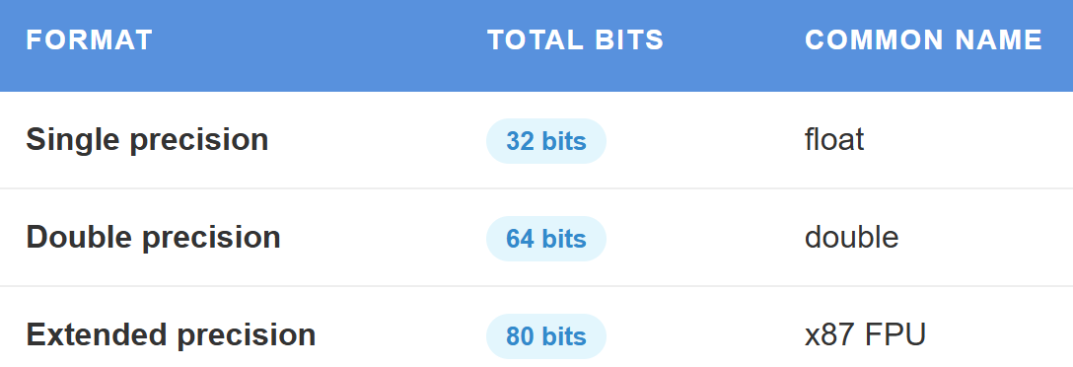

For now, we focus on **single precision (32-bit)**.

Single-Precision Floating-Point Layout (32-bit)

A 32-bit floating-point number is split like this:



* Sign → 1 bit
* Exponent → 8 bits
* Fraction (significand) → 23 bits

📌 The leading 1 of the significand is **implicit** (not stored).

Normalized Representation (Why the Hidden Bit Exists)

Binary floating-point numbers are stored in **normalized form**: 1.xxxxx × 2e

That leading 1 is always there (except special cases).

So instead of wasting a bit storing it:

* The CPU assumes it
* Gains one extra bit of precision

This is called:

**The hidden (implicit) bit**

Exponent Bias (Why Exponents Aren’t Signed)

Exponents are stored using a **bias**.

For single precision:

* Bias = **127**

Stored exponent:



This allows:

* Positive exponents
* Negative exponents
* Without signed arithmetic

Special Values (Where Things Get Weird)

IEEE 754 defines special cases:

* Exponent = 0 → denormalized numbers
* Exponent = all 1s:
  + Fraction = 0 → ±Infinity
  + Fraction ≠ 0 → NaN (Not a Number)

These exist so:

* Division by zero doesn’t crash
* Invalid operations are detectable

Why x86 Cares So Much About This

Floating-point representation affects:

* Performance
* Precision
* Security
* Stability

In x86:

* FPU uses 80-bit extended precision
* SSE often uses 32/64-bit precision
* Mixing them causes subtle bugs

This is why:

Floating-point bugs are some of the hardest bugs to find

Reverse Engineering Perspective **🔍**

When reversing:

* Floating-point constants may look “wrong”
* Precision may change across instructions
* Comparisons may fail unexpectedly

Never assume:

Floating-point equality means equality

Always think:

Approximation

Summary (No Fluff)

Floating-point numbers:

* Are stored as sign + significand + exponent
* Use base-2 scientific notation
* Follow IEEE 754 rules
* Trade exactness for range

This trade-off is intentional.

Lock-In Questions

1. Why can’t most decimals be represented exactly in binary?
2. Why does IEEE 754 use a hidden bit?
3. Why does exponent bias exist?
4. Why can mixing FPU and SSE cause bugs?

FLOATING-POINT FORMATS (IEEE 754)

I. Single-Precision Floating-Point Format (32-bit)

Single precision uses **32 bits** to represent a real number.

These 32 bits are divided into **three fields**:

* **Sign** → 1 bit
* **Exponent** → 8 bits
* **Significand (Mantissa)** → 23 bits

Visually:



⚠️ Important clarification  
**Bit layout and memory layout are different things**.  
The *bit fields* are defined logically as above,  
but **x86 stores bytes in little-endian order in memory**.

II. The Sign Bit

The **sign bit** is the most significant bit (MSB).

* 0 → positive number
* 1 → negative number

Example:

* 0.0 → positive zero
* -0.0 → negative zero (yes, this exists in IEEE 754)

The sign bit does **nothing else** — it only sets the sign.

III. The Significand (Mantissa)

The **significand** holds the **actual value digits** of the number.

In single precision:

* Stored bits → **23**
* Real precision → **24 bits**

Why 24?

Because IEEE 754 uses a **hidden leading 1**.

All normalized numbers are stored as: **1.xxxxx × 2e**

The 1 is **not stored** — it is **assumed**.

This gives one extra bit of precision “for free”.

IV. The Exponent

The **exponent** controls the **scale** of the number.

In IEEE 754:

* Exponent is stored using a **bias**
* Single-precision bias = **127**

Stored exponent: **stored = real_exponent + 127**

This avoids signed arithmetic and allows:

* Very large numbers
* Very small numbers

V. Positional Notation (Why This Works)

Floating-point is an extension of **positional notation**.

Decimal example: **123.154**

This expands to:

(1 × 10²) +

(2 × 10¹) +

(3 × 10⁰) +

(1 × 10⁻¹) +

(5 × 10⁻²) +

(4 × 10⁻³)

Each digit has:

* A value
* A position
* A weight

VI. Binary Positional Notation (Floating-Point Reality)

Binary floating-point works the **same way**, but with base-2.

Example structure: **1.101011 × 2e**

Digits to the left:

* Positive powers of 2

Digits to the right:

* Negative powers of 2

The significand stores these binary digits.

VII. Why Floating-Point Is Approximate **⚠️**

Most decimal numbers: Cannot be represented exactly in binary

Example: **0.1 (decimal)**

Becomes: **0.0001100110011... (binary, infinite)**

So floating-point numbers are:

**Approximations, not exact values**

This is why:

* 0.1 + 0.2 ≠ 0.3
* Equality comparisons are dangerous

VIII. Why Single Precision Is Useful

Single precision:

* Uses less memory
* Is faster on many systems
* Is good enough for graphics, games, and many simulations

But:

* Limited precision
* More rounding error than double precision

DOUBLE & EXTENDED PRECISION FORMATS

IX. Double-Precision Floating-Point (64-bit)

Double precision uses **64 bits**:

* Sign → 1 bit
* Exponent → 11 bits
* Significand → 52 bits (53 with hidden bit)

Advantages:

* Much higher precision
* Larger range
* Fewer rounding errors

This is:

* The default double in C/C++
* The standard in scientific computing

X. Extended Double Precision (80-bit)

Extended precision uses **80 bits**.

This format is mainly used by: The **x87 FPU**

Layout:

* Sign → 1 bit
* Exponent → 15 bits
* Significand → **64 bits (explicit)**

Unlike single/double:

* The leading bit is **stored**, not hidden
* Precision is extremely high

This is why:

* x87 calculations sometimes differ from SSE results
* Floating-point bugs appear when mixing units

XI. Support and Practical Use

* **Single precision (32-bit)** → graphics, embedded, performance-critical code
* **Double precision (64-bit)** → scientific, financial, engineering work
* **Extended precision (80-bit)** → internal FPU math, high-accuracy computations

Extended precision:

* Is not consistently supported across platforms
* Is often avoided in portable code

XII. Summary

* Floating-point uses **sign + significand + exponent**
* IEEE 754 defines the rules
* Precision is traded for range
* Single ≠ Double ≠ Extended
* Binary floating-point is approximate by design

If you don’t internalize this:

Floating-point bugs will feel like black magic.

If you do, they become predictable and debuggable.

Here is a table comparing double precision and double extended precision:

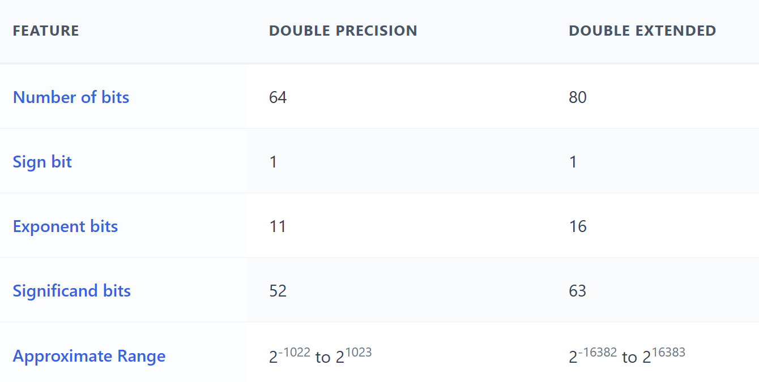

Single-Precision Floating-Point (32-bit)

* A **single-precision floating-point number** uses **32 bits** in total.
* It is split into **three parts**.

Sign Bit (1 bit)

* Tells if the number is **positive or negative**
* 0 → positive
* 1 → negative

Exponent (8 bits)

* Shows the **power of 2**
* It scales the number (makes it bigger or smaller)

Significand (23 bits)

* Also called the **mantissa**
* Stores the **fractional part** of the number
* Controls the **precision**

I. Bit Layout (Left to Right)

* **Sign bit** → first (most significant bit)
* **Exponent** → next 8 bits
* **Significand** → last 23 bits

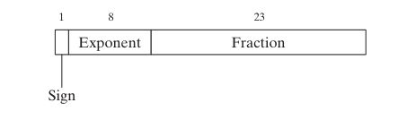

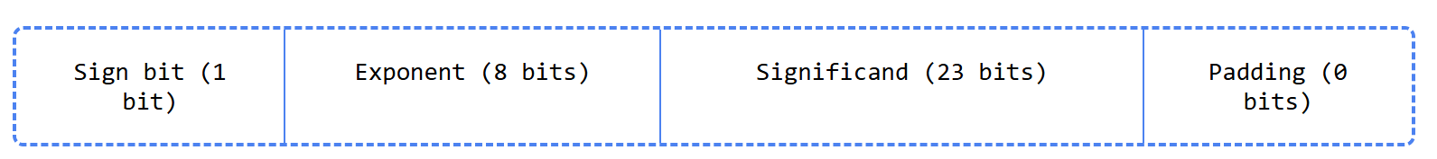

The padding bits are zeros that are not used in the floating-point representation.

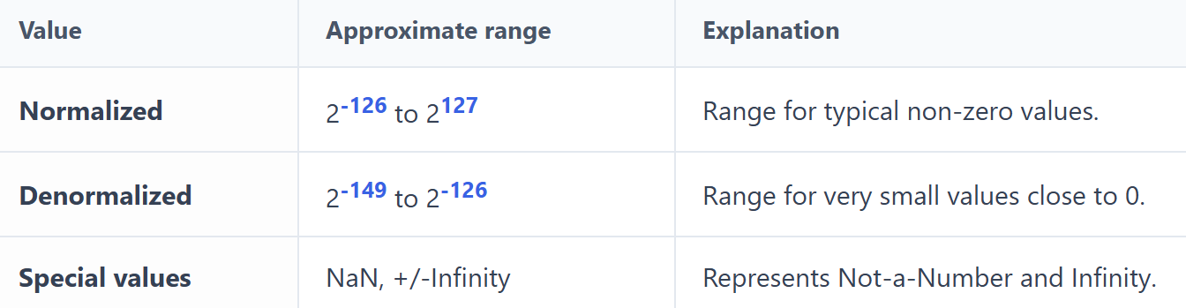

II. Normalized Numbers

* The **most common** floating-point numbers
* The **significand is between 1 and 2**
* **2 is not included**
* Used for most normal calculations

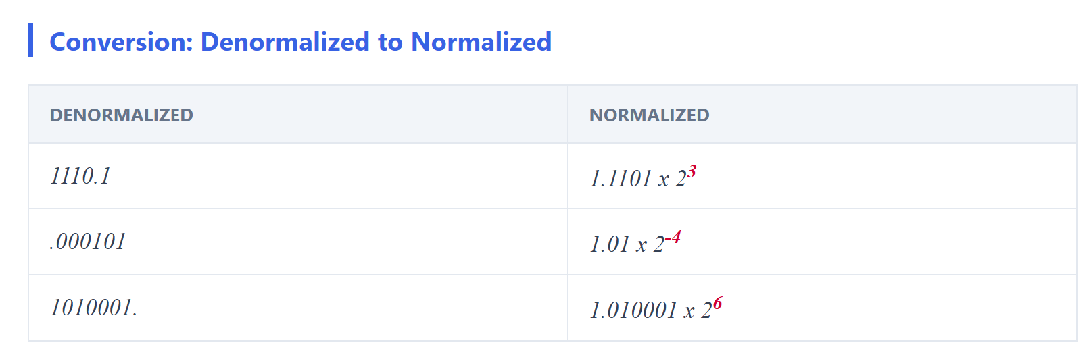

III. Denormalized Numbers

* The **significand is less than 1**
* Used to represent **very small numbers**
* Helpful for values **close to zero**

IV. Special Values

* **Special values** represent **NaN** and **Infinity**

V. NaN (Not a Number)

* Means the result is **undefined**
* Happens when a value **cannot be represented**
* Example: 0 ÷ 0

VI. Infinity (+∞ and −∞)

* Represents numbers that are **too large or too small**
* +∞ → positive infinity
* −∞ → negative infinity
* Often caused by **overflow or underflow**

Single-Precision Floating-Point (Overview)

* A **widely used** floating-point format
* Used in:
  + Scientific computing
  + Graphics
  + Gaming

I. Sign

* The **sign bit** shows if the number is positive or negative
* 0 → positive
* 1 → negative
* **Zero is treated as positive**

II. Significand

* The **significand** stores the **fractional part** of the number
* Made of digits **before and after** the decimal point

III. Exponents in the Significand

* Digits **left of the decimal point** → positive powers
* Digits **right of the decimal point** → negative powers

FLOATING-POINT SIGNIFICAND & PRECISION (CLEAN REBUILD)

I. Decimal Positional Notation (Baseline Idea)

Take the decimal number: **123.154**

This is just positional notation:

**123.154 =**

**(1 × 10²) +**

**(2 × 10¹) +**

**(3 × 10⁰) +**

**(1 × 10⁻¹) +**

**(5 × 10⁻²) +**

**(4 × 10⁻³)**

The significand here is: **123.154**

And the **base** is 10.

This idea carries directly into binary floating-point — only the **base changes**.

II. Binary Positional Notation

Binary works exactly the same way, but with **base 2**.

Example: **11.1011₂**

Expand it:

**11.1011₂ =**

**(1 × 2¹) +**

**(1 × 2⁰) +**

**(1 × 2⁻¹) +**

**(0 × 2⁻²) +**

**(1 × 2⁻³) +**

**(1 × 2⁻⁴)**

So far, this is **not floating-point yet** — this is just a binary real number.

III. Normalization (THIS IS KEY **🔑**)

IEEE floating-point **never stores numbers like 11.1011**.

It **normalizes** them. Rule:

A normalized binary floating-point number has exactly one 1 to the left of the binary point.

So: 11.1011₂

Becomes: **1.11011₂ × 2¹**

Now we can identify the components:

* **Significand (mantissa)** → 1.11011
* **Exponent** → +1

This is the form IEEE 754 always uses.

IV. The Hidden Leading 1 (Why Precision Is Higher Than It Looks)

In IEEE 754 **normalized numbers**:

* The leading 1 **is not stored**
* It is **implicitly assumed**

So, when we say: “The first bit of the significand is always 1”

That’s true **only for normalized numbers**.

Stored bits: **.11011**

Actual value: **1.11011**

This is why:

* Single precision has **23 stored bits**
* But **24 bits of precision**
* Double precision has **52 stored bits**
* But **53 bits of precision**

V. Exponent = Scaling, Not Changing the Value

Floating-point numbers can represent the **same value** using different exponent–significand pairs.

But ⚠️ our earlier example mixed base-10 notation with base-2 meaning, so let’s fix that.

**Correct binary-based explanation -** These represent **different values**, not the same:

**1.23456789 × 2¹⁰**

**1.23456789 × 2⁹**

**1.23456789 × 2⁸**

Each exponent change multiplies or divides by **2**, not 10.

The **significand stays the same**, the **scale changes**.

That’s how floating-point covers:

* Very small numbers
* Very large numbers

VI. Precision of the Significand

**Precision** = number of bits available to store the significand.

**IEEE formats:**

* **Single precision**
  + 23 stored bits
  + 24 bits of precision (hidden 1)
* **Double precision**
  + 52 stored bits
  + 53 bits of precision

This means:

A double can distinguish between about  
**2⁵³ different values** within a range

VII. Why Not All Real Numbers Can Be Represented **⚠️**

This is unavoidable.

* Real numbers are **infinite**
* Floating-point representations are **finite**

So, some numbers must be approximated. Example: **0.1₁₀**

In binary: **0.00011001100110011… (repeating forever)**

It **never terminates**.

So, the number is **rounded**.

VIII. Precision Limit Example

If a number requires **more bits than the format allows**, it cannot be represented exactly.

In double precision:

* Max significand precision = **53 bits**

Any binary value needing **54 or more bits**:

* Must be rounded
* Loses exactness

This is **not a bug**.  
This is **mathematics colliding with hardware limits**.

IX. Summary **🧠**

* Floating-point = **sign × significand × 2^exponent**
* Numbers are **normalized**
* Leading 1 is **hidden**
* Precision is **finite**
* Many decimals are **approximations**
* Equality comparisons are dangerous
* Understanding this saves **years of confusion**

Exponent (Floating-Point Numbers)

The **exponent** shows how many times the **significand is multiplied by 2**

It controls the **size** of the number

Example:

* 1.1011 × 2⁵
* The significand 1.1011 is multiplied by **2 five times**

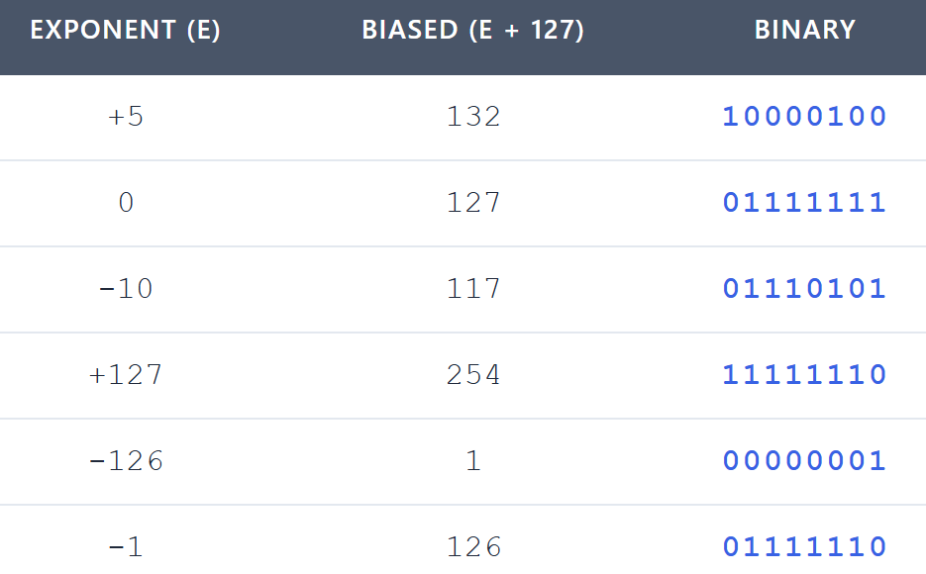

I. Biased Exponent

* The exponent is stored using a **bias**
* This keeps the stored value **positive**

II. Single-Precision Details

* Exponent size: **8 bits**
* Bias value: **127**
* Stored as an **unsigned integer**

III. Exponent Ranges

* **Biased exponent range:** 1 to 254
* **Actual exponent range:** -126 to +127
* This range prevents **overflow** for very small values

Calculating the Biased Exponent

Biased exponent = actual exponent + 127

Example:

* 1.1011 × 2⁵
* Actual exponent = 5
* Biased exponent = 127 + 5 = 132

Translating Binary Floating-Point to Fractions

The table below shows examples of how binary floating-point numbers can be translated into base-10 fractions.

* The **first column** lists the binary floating-point number.
* The **second column** shows the equivalent base-10 fraction.
* The **third column** gives the decimal value of that fraction.



I. Below is a quick explanation of each row in the table:

**Row 1:**

* Binary floating-point number: **11.11**
* Base-10 fraction: **3 3/4**
* Decimal value: **3.75**

**Row 2:**

* Binary floating-point number: **101.0011**
* Base-10 fraction: **5 3/16**
* Decimal value: **5.1875**

**Row 3:**

* Binary floating-point number: **1101.100101**
* Base-10 fraction: **13 37/64**
* Decimal value: **13.58125**

**Row 4:**

* Binary floating-point number: **0.00101**
* Base-10 fraction: **5/32**
* Decimal value: **0.15625**

**Row 5:**

* Binary floating-point number: **1.011**
* Base-10 fraction: **1 3/8**
* Decimal value: **1.375**

**Row 6:**

* Binary floating-point number: **0.00000000000000000000001**
* Base-10 fraction: **1/8,388,608**
* Decimal value: **0.0000011920928955078125**

II. How to Translate a Binary Floating-Point Number

To convert a binary floating-point number into a base-10 fraction, follow these steps:

* Convert the **significand** to a decimal value.
* Multiply the significand by **2 raised to the power of the exponent**.
* Check the **sign bit**: if it’s 1, the result is negative; if it’s 0, the result is positive.

III. Example: Converting 11.11

Let’s walk through the binary floating-point number **11.11** step by step:

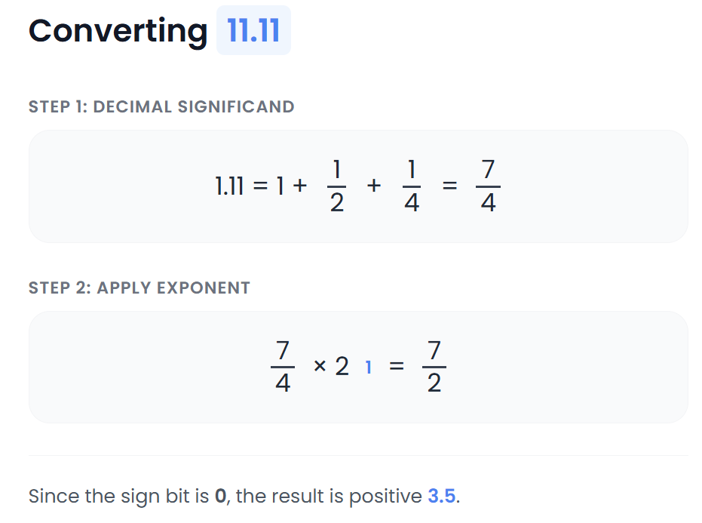

IV. Understanding the Exponent

To find the value of a floating-point number, simply multiply the significand by **2 raised to the exponent**.

For example:  
**1.1011 × 2³**

Here, the exponent is **3**, which means the significand **1.1011** is multiplied by 2 three times.

The exponent tells us how much to scale the significand. Since this is a binary number, the base is always **2**.

In this case, the exponent was chosen so the final value falls between **1 and 2**.

* A smaller exponent would make the value less than 1.
* A larger exponent would make the value greater than 2.

V. Why Floating-Point Numbers Matter

Floating-point numbers are powerful because they let us represent both extremely small and extremely large values.

The exponent makes this possible by scaling the significand up or down as needed—giving us flexibility without losing precision.

Binary mapping to decimal mapping

Let’s discuss another table:

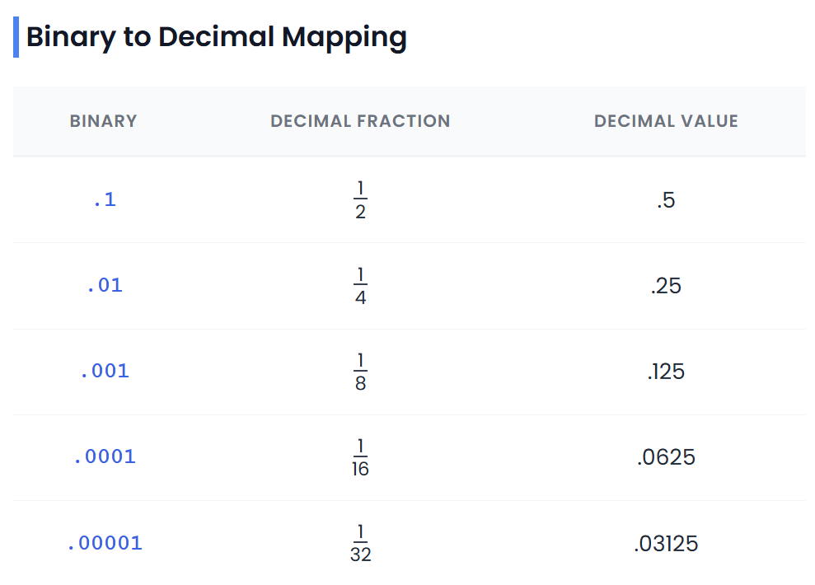

To convert from **binary to decimal**, we multiply each digit in the binary number by its corresponding power of two, then add all the results together.

For example, to convert the binary fraction **0.1011** to decimal, each digit is multiplied by a negative power of 2 based on its position:

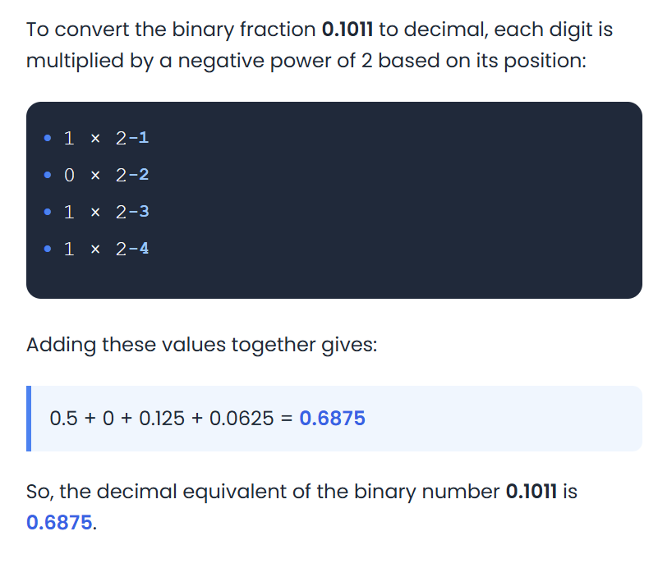

To convert from **decimal to binary**, we repeatedly divide the decimal number by 2 and record the remainder at each step.

The remainders, read in reverse order, form the binary representation of the number. For example, to convert the decimal number **2.0761** to binary, we would do the following:

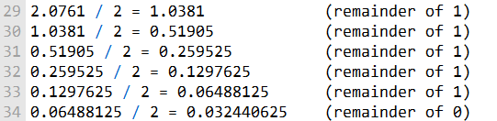

The binary representation of 2.0761 is therefore 1.0111.

Floating-point numbers can represent a much wider range of values by using more bits.

CREATING THE IEEE REPRESENTATION

**CREATING THE IEEE REPRESENTATION**

The passage below explains how to create the IEEE representation of a floating-point number.

The first step is to normalize the sign bit, exponent, and significand fields. This means adjusting the significand so that its leading bit is 1.

For example, the significand **1.1011** can be normalized by shifting the bits one position to the left, resulting in the normalized significand **11.011**.

Next, the sign bit, exponent, and significand fields are encoded.

The sign bit is stored as a single bit: **0** represents a positive number, and **1** represents a negative number.

The exponent is stored as an 8-bit unsigned integer using a bias of **127**. This means the actual exponent is added to 127 to produce the biased exponent.  
For example, an actual exponent of **5** is encoded as the biased exponent **132**.

The significand is stored as a 23-bit unsigned integer. The leading bit of the normalized significand is not stored explicitly, since it is always assumed to be 1.  
As a result, the significand **11.011** is encoded as the 23-bit value **01000100000000000000000**.

Once the sign bit, exponent, and significand fields are encoded, they are combined to form the complete IEEE short real.  
The following table shows an example of how to create the IEEE representation of the floating-point number **1.101 × 2²⁰**:

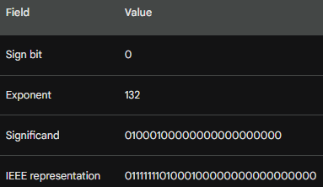

The IEEE representation of a floating-point number allows computers to store and work with real numbers efficiently.

IEEE floating-point numbers are used all over the place, including scientific computing, computer graphics, and gaming.

The table below shows the **binary value**, **exponent**, **sign bit**, and **significand** for several IEEE floating-point numbers. Below is a concise explanation of what each row represents:

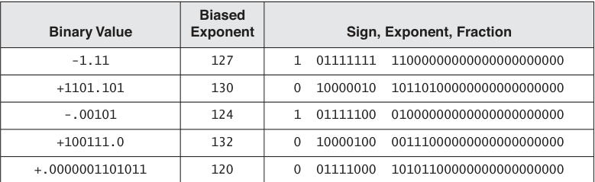

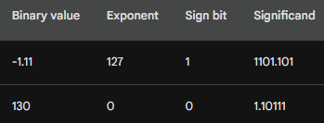

IEEE 754 FLOATING-POINT ENCODINGS (REBUILT)

I. Interpreting an IEEE Floating-Point Bit Pattern

An IEEE single-precision floating-point number consists of:



The value is computed as:



Where:

* Bias = **127**
* Significand = 1.fraction (for normalized numbers)

II. Correcting the Example Interpretations **⚠️**

**❌ Common mistakes in the original text**

* Saying “exponent = 127 is the largest possible exponent” → **false**
* Mixing **binary fractions** with **decimal meanings**
* Using **unbiased exponent = 0** incorrectly
* Calling raw binary strings “IEEE values” without normalization context

Let’s fix this cleanly.

III. Normalized Finite Numbers

A **normalized** IEEE number satisfies:

* Exponent field ≠ 00000000
* Exponent field ≠ 11111111
* Leading significand bit is **implicitly 1**

Example (Corrected):

Bit pattern: **0 10000010 01011000000000000000000**

Breakdown:

* **Sign bit** = 0 → positive
* **Exponent bits** = 10000010₂ = 130₁₀
* **Unbiased exponent** = 130 − 127 = 3
* **Fraction bits** = 01011000000000000000000

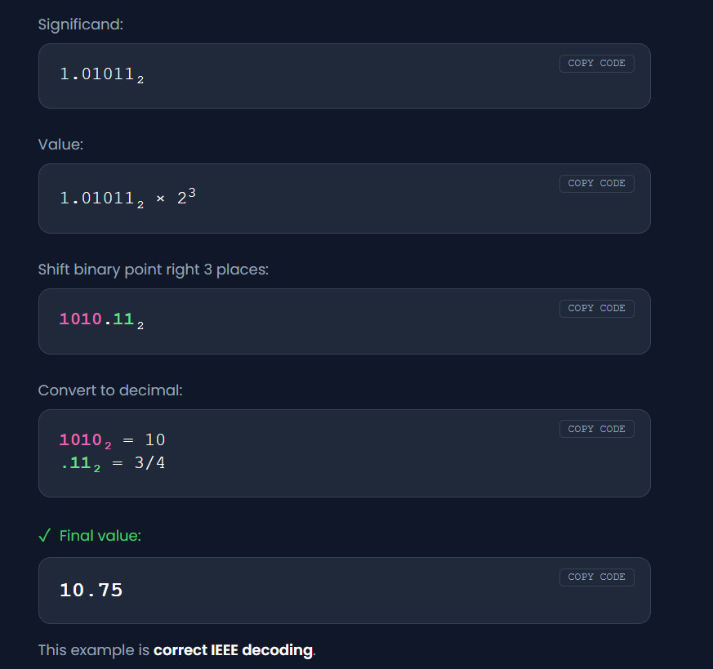

IV. Special IEEE Encodings

IEEE 754 defines **real numbers AND non-numbers**.

1. Positive and Negative Zero

* Exponent = 00000000
* Fraction = all zeros
* Sign bit distinguishes +0 and −0

These compare equal numerically but **behave differently in edge cases**.

2. Normalized Finite Numbers

* Exponent ∈ [1, 254]
* Leading significand bit = 1
* Highest precision

This is what **most real numbers use**.

3. Denormalized (Subnormal) Numbers ⚠️

Used for values **too small** to be normalized.

Conditions:

* Exponent = 00000000
* Leading significand bit = **0** (not implicit 1)
* Exponent is fixed at:

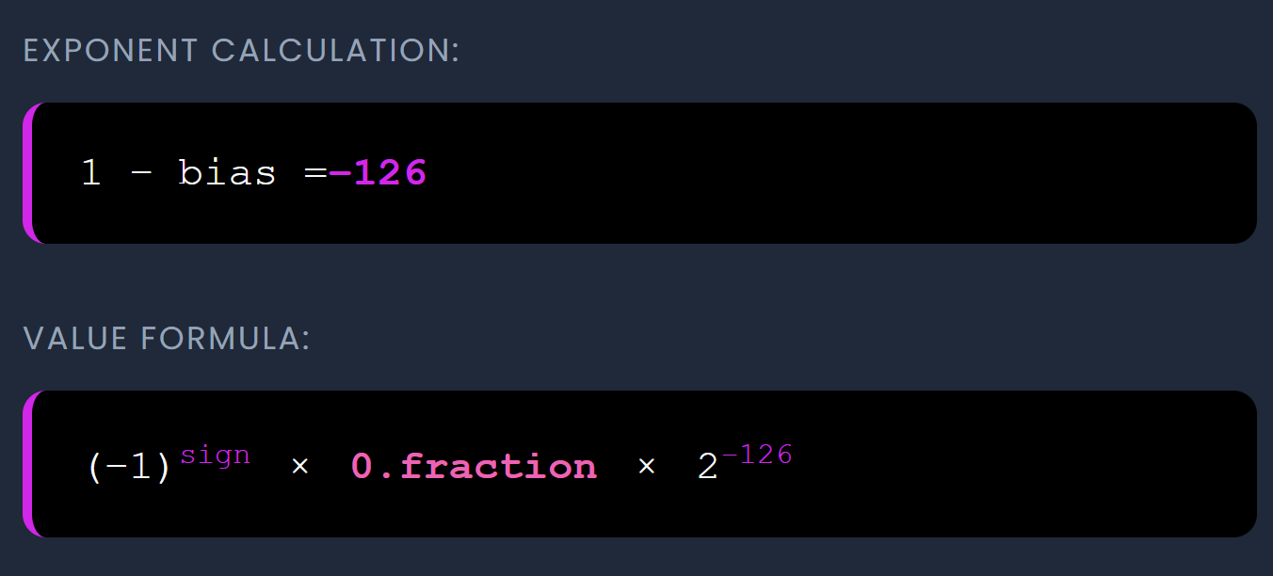

V. Why Denormalization Exists (Very Important)

Without denormals:

* There would be a **sudden jump to zero**
* This causes numeric instability

Denormals allow:

* Gradual underflow
* Smoother behavior near zero
* Better numerical algorithms

VI. Correct Denormalization Example (Cleaned)

Original number: **1.01011110000000000001111 × 2⁻129**

This exponent is **below −126**, so it **cannot be normalized**.

The FPU:

* Fixes exponent at −126
* Shifts the significand **right**
* Loses precision gradually

After shifting:



Key points:

* Leading bit is **0**
* Precision is reduced
* Value is still representable

This is **subnormal behavior**, not “magic”.

VII. Infinity and NaN

Positive / Negative Infinity

* Exponent = 11111111
* Fraction = all zeros
* Sign bit determines +∞ or −∞

Used for:

* Divide by zero
* Overflow

NaN (Not a Number)

* Exponent = 11111111
* Fraction ≠ zero

Used for:

* Invalid operations (0/0, ∞−∞)
* Propagates through calculations

⚠️ NaN **never equals anything**, including itself.

VIII. “Indefinite” Values (x87 Context)

On x87 FPU:

* Certain invalid operations produce **indefinite values**
* Encoded as **specific NaNs**
* Often seen when reversing legacy binaries

This is why x87 dumps look weird compared to SSE.

IX. Converting IEEE Single-Precision to Decimal (FINAL CLEAN STEPS)

**Step-by-step (Correct Version)**

1. Read **sign bit**
2. Extract **exponent**
   * Subtract bias (127)
3. Extract **fraction**
   * Add implicit leading 1 (unless denormal)
4. Form:



1. Shift binary point
2. Convert using positional notation

That’s it. No shortcuts.

X. Why This Matters for Reverse Engineering **🧠**

* Floating constants in binaries
* x87 stack dumps
* SSE registers (XMM)
* Malware anti-analysis tricks
* Precision bugs
* Compiler artifacts

If you **misunderstand IEEE**, you misread behavior.

XI. Summary

* IEEE is deterministic, not mysterious
* Normalized ≠ Denormalized
* Exponent bias matters
* Precision is finite
* Some numbers **cannot** be exact
* Zero has two signs
* NaN breaks comparisons
* This shows up **everywhere** in low-level code

POSITIVE AND NEGATIVE INFINITY

Special Floating-Point Values: Infinity & NaNs

* **Positive and Negative Infinity** In floating-point math, infinity isn’t just a concept—it’s an actual special value.
  + **Positive infinity** represents numbers that are too large to fit in the normal range.
  + **Negative infinity** represents numbers that are too small (on the negative side). These values pop up when operations “overflow,” like dividing by zero or adding a huge number to a tiny one.
* **NaNs (Not a Number)** Sometimes math goes off the rails—like dividing zero by zero or trying to take the square root of a negative number. The result isn’t a valid real number, so computers use **NaNs** to stand in.
  + A NaN is basically a special bit pattern that says: *“This isn’t a real number, but I need to represent the result somehow.”*
  + There are two flavors: **quiet NaNs** (which silently propagate through calculations) and **signaling NaNs** (which raise exceptions to flag errors).
* **IEEE Standard Encodings** The IEEE floating-point standard defines exactly how these special values are stored in memory. There are specific encodings for:
  + Positive infinity
  + Negative infinity
  + Quiet NaNs

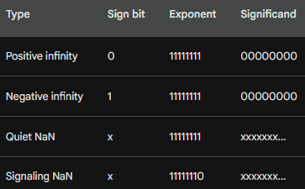

How FPUs Handle Infinity and NaNs

* **NaN’s Significand Field** For NaNs, the significand (the fraction part of the floating-point number) can actually be *anything*. That’s part of what makes NaNs flexible placeholders for “not-a-number” results.
* **Special Treatment by FPUs** Floating-point units (FPUs) don’t just crunch numbers blindly—they have built-in rules for handling these special values:
  + If an operation would blow up into **positive or negative infinity**, the FPU doesn’t crash—it simply returns the matching infinity value.
  + If an operation leads to a **NaN**, the FPU returns a NaN instead. In some cases, it may also raise an exception to let the system know something unusual happened.
* **Consistency Across Systems** All of this behavior isn’t random—it’s carefully defined by the **IEEE floating-point standard**. Thanks to this standard, FPUs from different manufacturers and architectures behave consistently. That means whether you’re running code on a laptop, a server, or a supercomputer, infinity and NaNs are handled the same way.



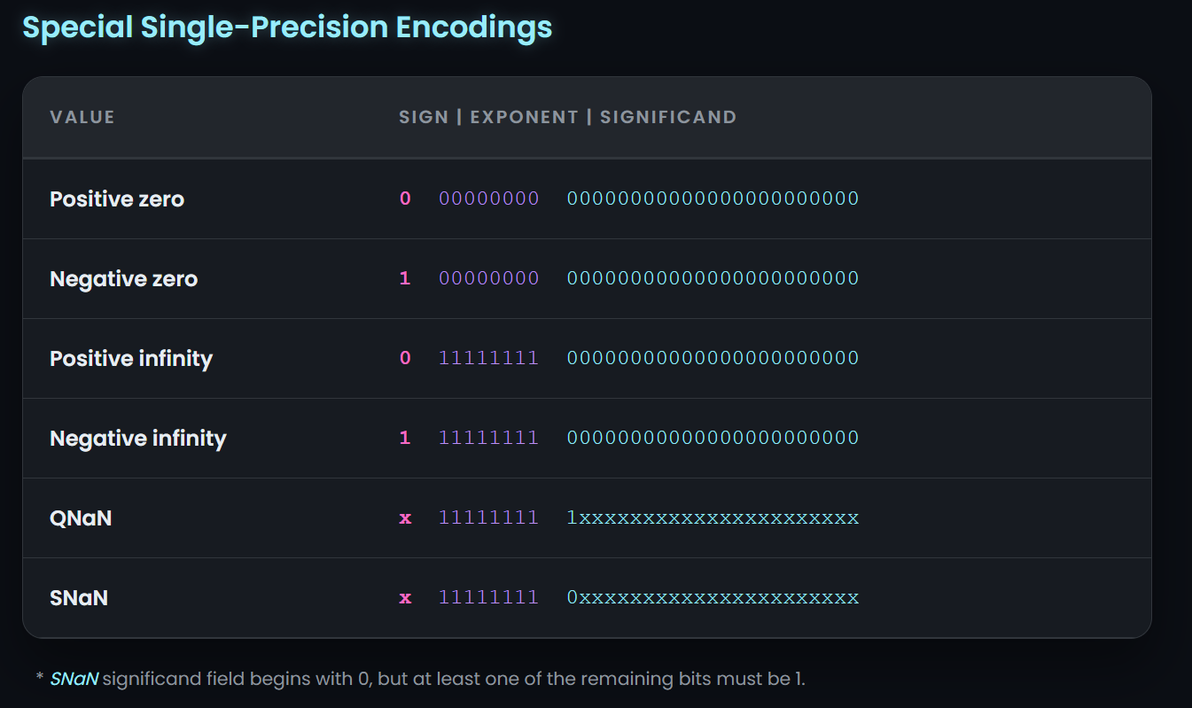

CONVERTING DECIMAL FRACTIONS TO BINARY REALS

Converting Decimal Fractions to Binary Reals

There are a couple of neat ways to turn decimal fractions into their binary equivalents. Let’s break them down:

* **Method 1: Breaking into Fractions**
  1. Write the decimal fraction as a sum of fractions like 1/2+1/4+1/8+….
  2. Convert each of those fractions into binary form.
  3. Add the binary fractions together to get the final binary result.
* **Method 2: Long Division in Binary**
  1. Convert both the numerator and denominator of the decimal fraction into binary.
  2. Perform long division using those binary numbers.
  3. The quotient you get is the binary representation of the decimal fraction.

**Example (Using Method 2)** Let’s try converting **0.5** into binary:

First, convert the numerator and denominator into binary.

* 5 in decimal → **101** in binary
* 10 in decimal → **1010** in binary

Next, perform long division on these binary numbers:

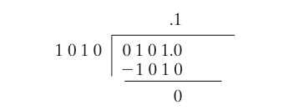

💡 **Tip:** Method 1 is often faster for simple fractions, while Method 2 is more general for any decimal fraction.

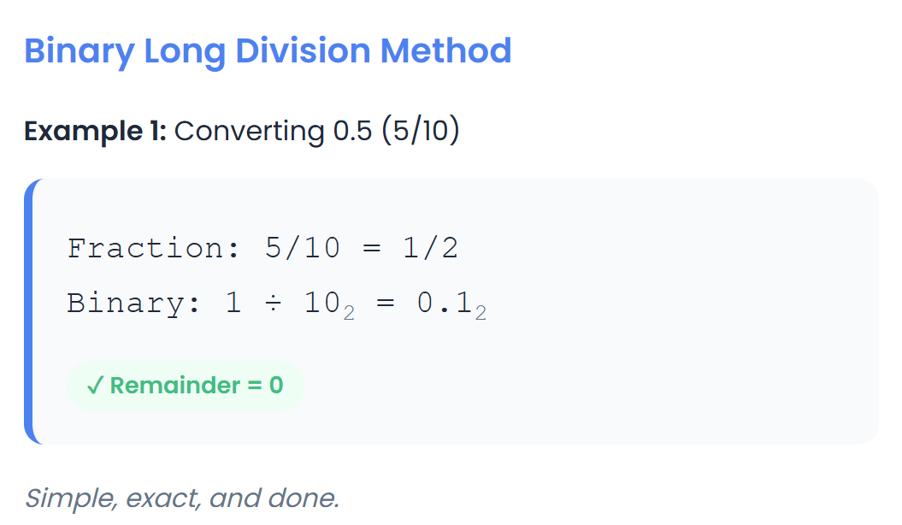

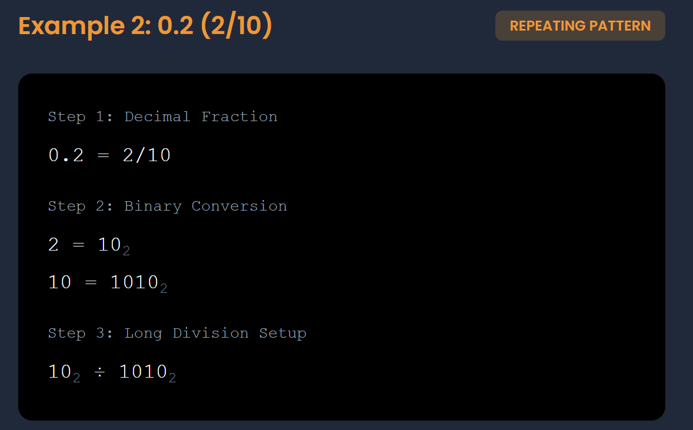



I. Key idea:

* Some decimal fractions, like 0.2, **cannot be represented exactly in binary** because their denominator (10) has prime factors other than 2.
* That’s why the division never stops cleanly.
* In single-precision floating-point (IEEE 754), we truncate or round the repeating sequence:
  + Significand for 0.2 ≈ 00110011001100110011001 (23 bits).

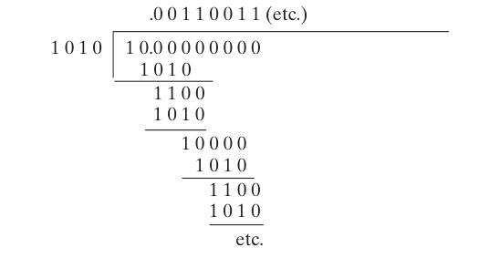

Examples of decimals factored as binary reals:

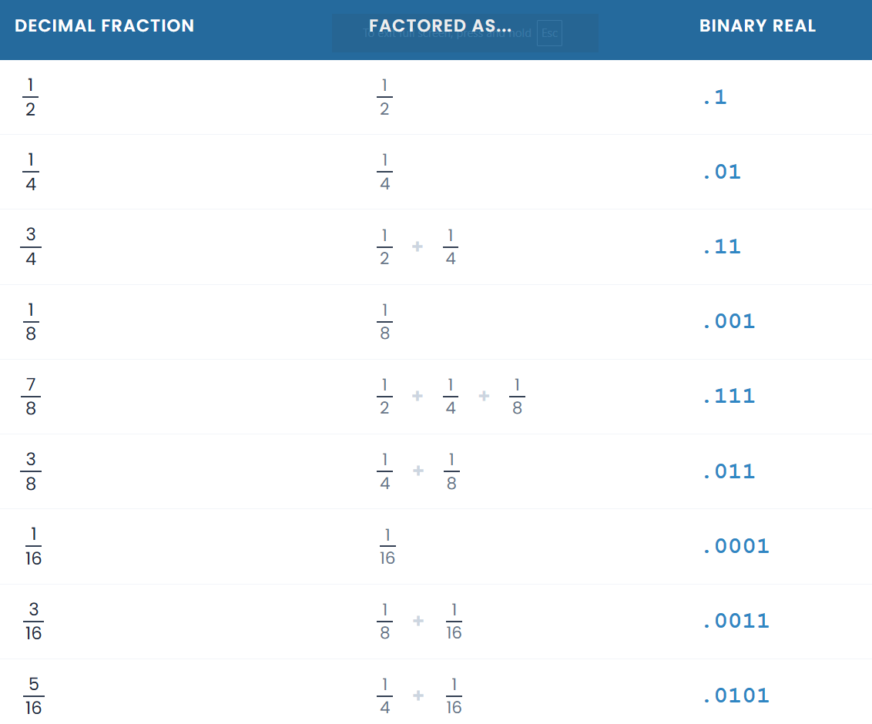

Think of this table like a **cheat sheet** for turning everyday fractions into computer language. Here is the simple breakdown of how it works:

II. How to read the table

* **Column 1 (The Fraction):** This is the normal decimal fraction you are starting with.
* **Column 2 (The Recipe):** This shows the ingredients (like 1/2 or 1/4) used to make that fraction.
* **Column 3 (The Binary):** This is the final code the computer understands.

III. Examples of how it works

* **The Basic 1/2:** To get 1/2, the recipe is just 1/2, and the binary is **.1**.
* **The Basic 1/4:** To get 1/4, the recipe is just 1/4, and the binary is **.01**.
* **Mixing Ingredients:** To get **3/4**, you mix 1/2 and 1/4 together (1/2 + 1/4). The binary becomes **.11** because you have a piece in both the "half" spot and the "quarter" spot.

IV. How to use it for yourself

1. **Find your fraction** in the first column.
2. **Look across** to the third column to find its binary code.
3. **Example:** If you need to convert **5/8**, you find it in the list and see the binary is **.101**.

V. A quick warning: The Infinity Glitch

* Most fractions are easy to convert, but **not all of them fit perfectly**.
* Binary only has a limited number of "slots" to use, but numbers can go on forever.
* Because of this, some numbers have to be **approximated** (rounded off), which is why computers sometimes have tiny rounding errors.

VI. An Analogy to keep it simple:

Imagine you have a set of **building blocks** that are only certain sizes: a 5-inch block, a 2.5-inch block, and a 1.25-inch block.

* If you want to build a tower exactly 7.5 inches tall, you just use the 5-inch and the 2.5-inch blocks.
* But if you want a tower that is exactly 7.1 inches tall, none of your blocks fit perfectly! You have to use the ones you have to get as close as possible. That is exactly what a computer does with binary fractions.

VII. How to Factor a Fraction

To find the "ingredients" for your fraction, follow these three simple steps:

1. **Find the biggest piece:** Look for the largest power of two (like 1/2, 1/4, 1/8) that fits inside your fraction.
2. **Subtract it:** Take that piece away from your total.
3. **Repeat:** Keep doing this with the leftover amount until you have nothing left.

The powers of two you subtracted are your **factors**.

VIII. A Real Example: Factoring 3/4

Let's see how we get the factors for **3/4**:

* **Step 1:** The biggest power of two that fits in 3/4 is **1/2**.
* **Step 2:** Subtracting 1/2 from 3/4 leaves you with **1/4**.
* **Step 3:** The biggest power of two that fits in 1/4 is **1/4**.
* **Step 4:** Subtracting 1/4 from 1/4 leaves you with **zero**.

**Result:** The factors of 3/4 are **1/2** and **1/4**.

IX. Converting Factors to Binary

Once you have your factors, you just need to know their binary "code":

* **Factor 1/2:** Divide 1 by 2. You get 0.5, which in binary is **.1**.
* **Factor 1/4:** Divide 1 by 4. You get 0.25, which in binary is **.01**.

**The Final Step:** Add the binary codes together.

Since **.1** + **.01** = **.11**, the binary version of **3/4** is **0.11**.

X. A quick analogy:

Imagine you are at a store and need to pay **75 cents** (3/4 of a dollar), but you can only use a **50-cent** coin (1/2) and a **25-cent** coin (1/4).

* You use one 50-cent coin (put a **1** in the first slot).
* You use one 25-cent coin (put a **1** in the second slot).
* Your total is **.11**.

Questions

**Why doesn't the single-precision real format permit an exponent of -127?**

The single-precision real format does not permit an exponent of -127 because it would generate a zero. This is because the unbiased exponent is calculated by subtracting 127 from the exponent. If the exponent is -127, then the unbiased exponent would be zero. However, the significand of a non-zero floating-point number cannot be zero. Therefore, an exponent of -127 is not permitted.

**Why doesn't the single-precision real format permit an exponent of 128?**

The single-precision real format does not permit an exponent of 128 because it would generate an overflow. This is because the unbiased exponent is calculated by subtracting 127 from the exponent. If the exponent is 128, then the unbiased exponent would be 1. However, the unbiased exponent cannot be greater than 255. Therefore, an exponent of 128 is not permitted.

**In the IEEE double-precision format, how many bits are reserved for the fractional part of the significand?**

The IEEE double-precision format reserves 52 bits for the fractional part of the significand. This gives double-precision floating-point numbers a much higher degree of precision than single-precision floating-point numbers.

**In the IEEE single-precision format, how many bits are reserved for the exponent?**

The IEEE single-precision format reserves 8 bits for the exponent. This gives single-precision floating-point numbers a range of values from 2-126 to 2127.

FLOATING POINT UNIT

Floating Point Unit (FPU)

1. **Definition:**
   * The **FPU** is a specialized processor or hardware unit designed to handle **floating-point arithmetic** efficiently.
   * Floating-point numbers are numbers with a fractional part (e.g., 3.14, -0.5, 2.0 × 10³).
2. **Registers:**
   * The FPU has its **own registers**, often organized as a **register stack**.
   * Registers are used to **temporarily store operands and results** during calculations.
3. **Operation:**
   * The FPU can **load values from memory** into the stack, **perform arithmetic operations**, and **store results back to memory**.
   * It performs calculations in **postfix (Reverse Polish) notation**:
     + **Postfix:** Operands come **before** the operator.
     + **Example:** Infix: (5 × 6) − 4 → Postfix: 5 6 * 4 −
4. **Why postfix?**
   * Postfix notation eliminates the need for parentheses.
   * The FPU can evaluate expressions **directly using a stack**, which simplifies hardware design.

💡 **Extra tip for notes:** Modern FPUs support single-precision (32-bit) and double-precision (64-bit) floating-point formats and handle special values like infinity, NaN, and denormal numbers. This gives a more complete picture.

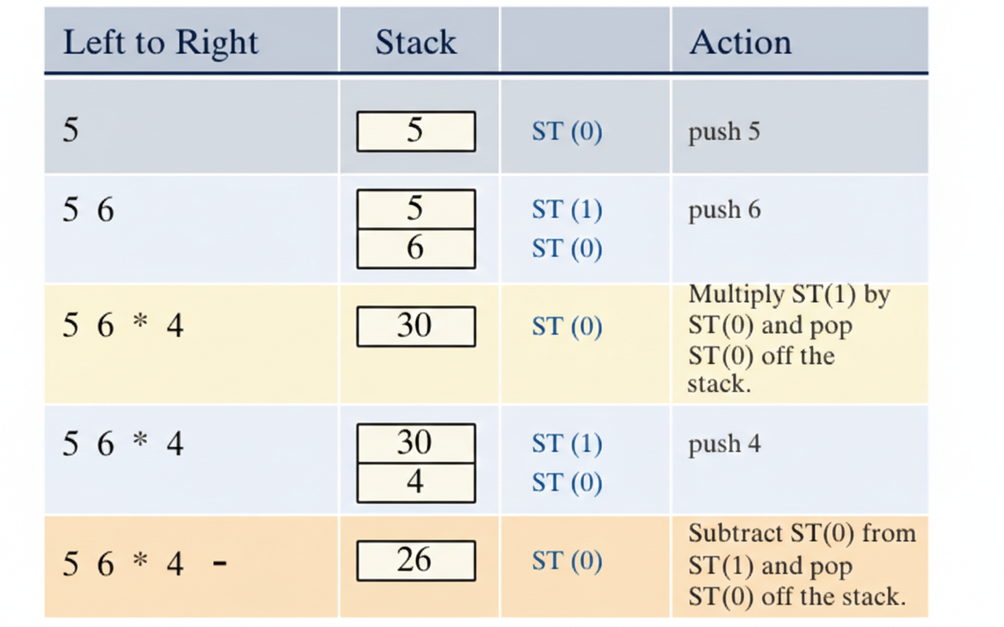

I. FPU Expression Stack and Postfix Evaluation

1. **Expression Stack:**
   * The FPU uses a **stack** to hold intermediate results during calculations.
   * The stack follows **LIFO (Last-In-First-Out)**:
     + **Last value pushed** → **first value popped**
2. **Postfix Expression Evaluation:**  
   To evaluate a postfix expression:
   * **Push operands** onto the stack as they appear.
   * When an **operator** appears, **pop the top two operands** from the stack.
   * **Perform the operation** and **push the result** back onto the stack.
   * Repeat until **all operators have been processed**.
   * The **final result** is the **only value left** on the stack.

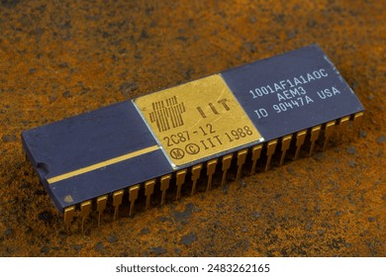

II. Example Table: Infix → Postfix

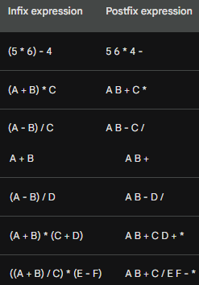

III. Postfix Expressions and FPU Evaluation

In postfix expressions, parentheses aren’t needed because the **order of operations** is already determined by the order of the operands.

For example, take the infix expression **(A + B) * (C + D)**. In postfix form, the expression could be written without parentheses, yet the multiplication still happens after the additions. That’s because **multiplication naturally has higher precedence than addition**, so the order is implied.

Here’s how an FPU would evaluate the simple postfix expression **A B +** using its **expression stack**:

1. **Expression stack:** empty
2. **Next operand:** A → push onto stack
   * **Expression stack:** A
3. **Next operand:** B → push onto stack
   * **Expression stack:** A, B
4. **Next operator:** + → pop the top two operands (A and B), perform the addition, and push the result back onto the stack
   * **Expression stack:** A + B

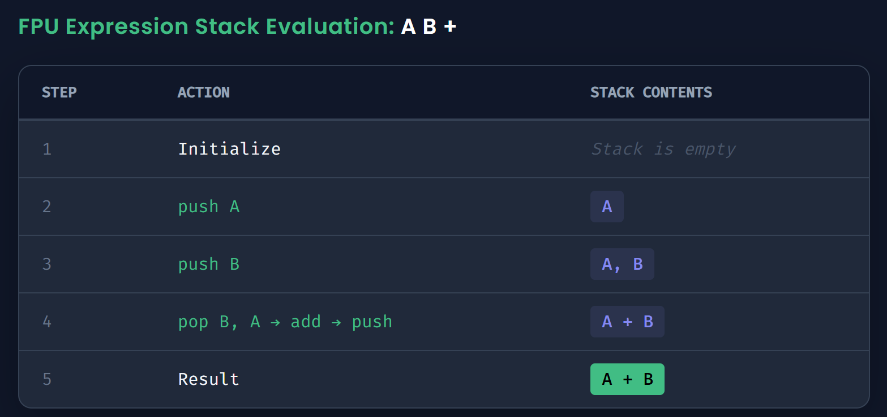

At this point, the FPU has no more operands or operators to process, so it stops. The final result is **A + B**.

This is the same process the FPU uses for **all postfix expressions**:

* Push operands onto the expression stack.
* Pop the top two operands when an operator appears.
* Perform the operation and push the result back onto the stack.
* Repeat until all operators are processed.

The **final value remaining on the stack** is the result of the expression.

FPU Data Registers

The FPU has **eight 80-bit data registers**, named **R0** through **R7**, which together form a **register stack**.

This stack operates in a **last-in, first-out (LIFO)** fashion—meaning the most recently pushed value is the first one to be popped off.

The **top of the stack** is tracked by a **three-bit field called TOP** in the FPU status word. The register at the top is referred to as **ST(0)**, while the remaining registers are labeled **ST(1), ST(2), …, ST(7)**, in order.

I. Pushing a Value

When you push a value onto the FPU stack:

* The FPU **decrements TOP by 1**.
* The value is copied into the register currently at **ST(0)**.
* If **TOP is 0 before the push**, it wraps around to **R7**.

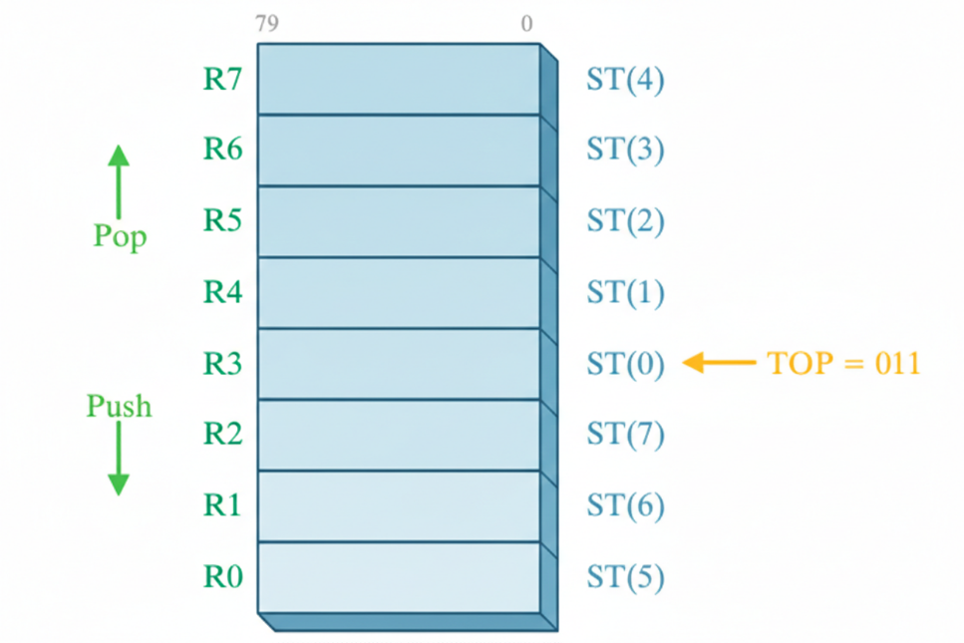

II. Popping a Value

When you pop a value from the stack:

* The FPU copies the data from **ST(0)** into your operand.
* **TOP is incremented by 1**.
* If **TOP is 7 before the pop**, it wraps around to **R0**.

III. Handling Stack Overflows

If you try to load a value into the stack **when it would overwrite existing data**, the FPU raises a **floating-point exception** to signal the problem.

The following diagram shows the FPU stack after 1.0 and 2.0 have been pushed onto the stack:

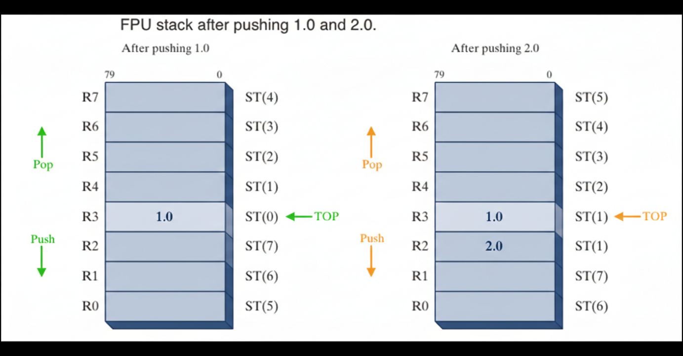

IV. How the FPU Performs Floating-Point Operations

To carry out a floating-point calculation, the **FPU** follows a simple cycle:

1. **Pop the operands** off the stack.
2. **Perform the operation** (addition, subtraction, multiplication, etc.).
3. **Push the result** back onto the stack.

**Example:** To compute **1.0 + 2.0**, the FPU:

* Pops **1.0** and **2.0** from the stack
* Adds them together to get **3.0**
* Pushes **3.0** back onto the stack

This stack-based system allows the FPU to perform calculations efficiently **without storing intermediate results in memory**, making it especially powerful for complex floating-point operations.

Key Features of the FPU

I. ST(n) Notation:

* The FPU refers to its stack registers using **ST(0), ST(1), …, ST(7)**.
* **ST(0)** always represents the **top of the stack**.
* This notation makes it easy to address data within the FPU’s **stack-based architecture**.

II. Floating-Point Value Format:

* Values in the FPU registers are stored in the **IEEE 10-byte extended real format**, sometimes called **temporary real**.
* When the FPU writes a result to memory, it can convert it into several formats:
  + **Integer**
  + **Long integer**
  + **Single precision**
  + **Double precision**
  + **Packed binary-coded decimal (BCD)**

The FPU’s combination of a **stack-based design** and flexible **value formats** allows it to handle a wide variety of calculations efficiently and accurately.

III. Special-Purpose Registers in the FPU

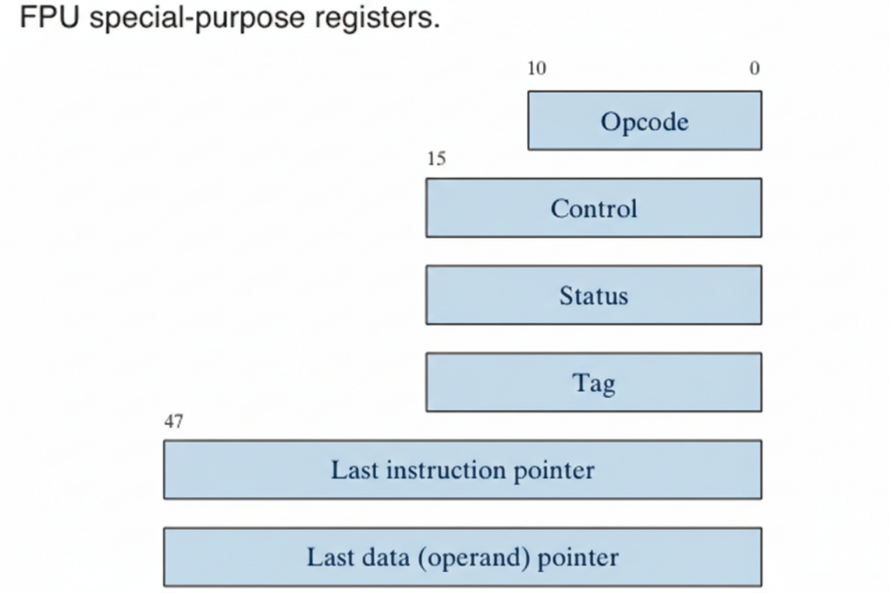

The **Floating-Point Unit (FPU)** has several special-purpose registers that help it manage operations and maintain precision:

* **Opcode Register:** Stores the opcode of the last non-control instruction executed.
* **Control Register:** Determines the **precision** and **rounding method** used during calculations. It can also **mask individual floating-point exceptions**.
* **Status Register:** Contains the **top-of-stack pointer**, **condition codes**, and information about **exceptions or warnings**.
* **Tag Register:** Tracks the content of each FPU data-register stack entry. It uses **two bits per register** to indicate whether the register holds a valid number, zero, a special value (NaN, infinity, denormal, unsupported format), or is empty.
* **Last Instruction Pointer Register:** Stores a pointer to the last non-control instruction executed.
* **Last Data (Operand) Pointer Register:** Stores a pointer to a data operand, if any, used by the last instruction.

**Why They Matter:**  
Operating systems use these registers to **preserve the FPU state** when switching between tasks. This is essential in **multitasking environments**, where the CPU frequently switches between different programs or threads.

IV. Rounding in the FPU

Floating-point calculations often produce results that **can’t be represented exactly** in the destination format. Rounding is used to adjust these results so they fit the available precision.

**Example:**

* Precise result: **1.0111**
* Destination format: **3 fractional bits**

Rounding options:

1. **Round up:** Add 0.0001 → **1.100**
2. **Round down:** Subtract 0.0001 → **1.011**

For negative values, the same logic applies:

* **-1.0111 → -1.100** (round up in absolute value)
* **-1.0111 → -1.011** (round down in absolute value)

V. FPU Rounding Methods

The FPU supports **four rounding methods**, controlled by the **RC (Rounding Control) field** in the **control word**:

1. **Round to Nearest Even (default):** Round to the nearest value. If two values are equally close, choose the even one (least significant bit = 0).
2. **Round Down Toward −∞:** Round to a value **less than or equal to** the precise result.
3. **Round Up Toward +∞:** Round to a value **greater than or equal to** the precise result.
4. **Round Toward Zero (Truncation):** Round toward zero; the absolute value of the result is **less than or equal to** the precise result.

VI. RC Field Binary Encoding:

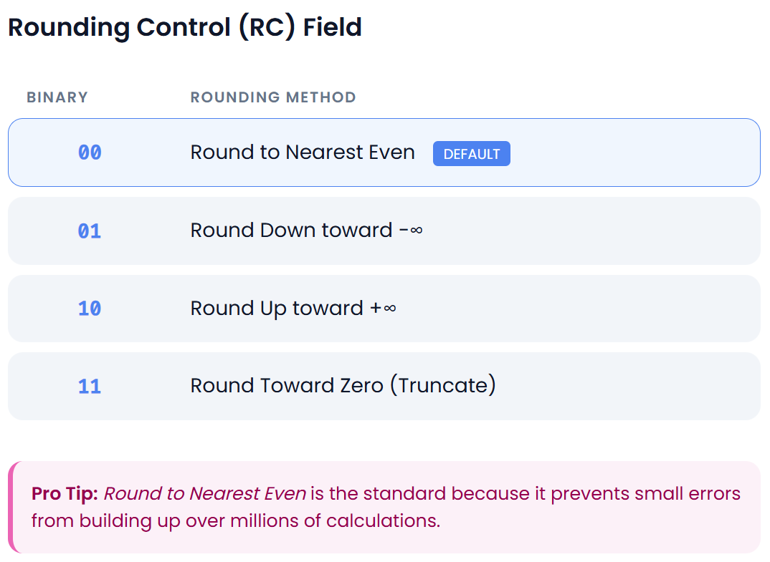

The tables below would show how these rounding methods would be applied to the binary values 1.0111 and -1.0111, respectively.

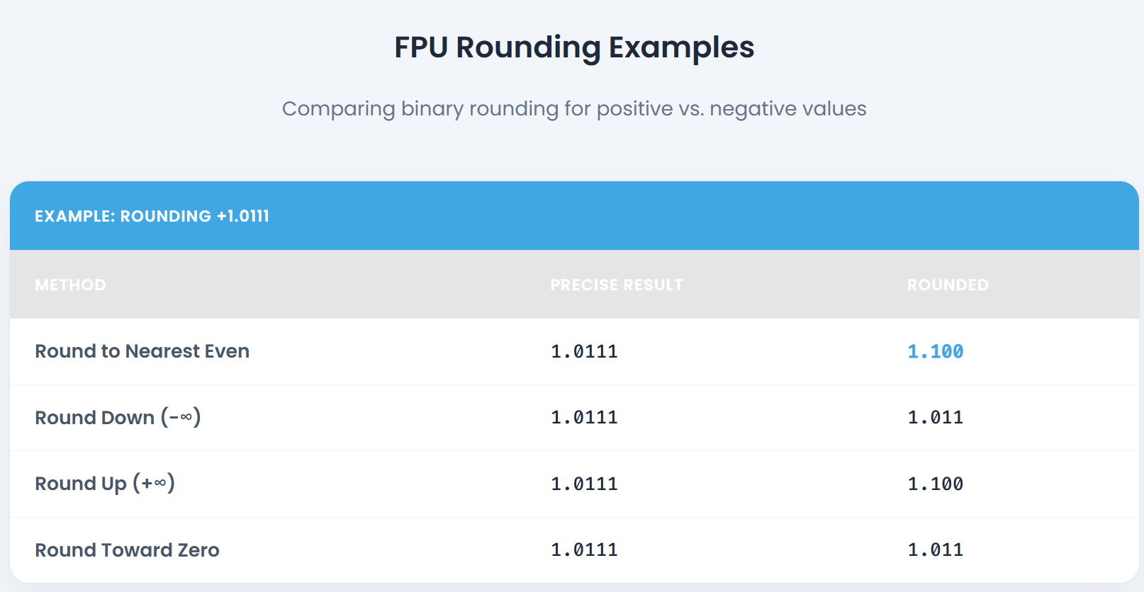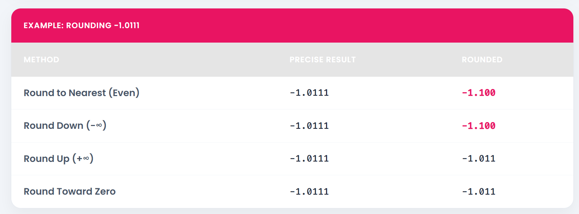

Rounding in floating-point arithmetic is essential to ensure that calculated results fit within the chosen format while minimizing error.

The method chosen depends on the specific requirements of the application.

FLOATING-POINT EXCEPTIONS

Floating-point exceptions are **errors that can occur during floating-point calculations**. The FPU recognizes six main types of exceptions:

1. **Invalid Operation (#I):**  
   Raised when an illegal operation is attempted, such as dividing **0 by 0** or taking the **square root of a negative number**.
2. **Divide by Zero (#Z):**  
   Triggered when a number is divided by **zero**.
3. **Denormalized Operand (#D):**  
   Occurs when an operation is attempted on a **denormalized number**, which is a number very close to zero.
4. **Numeric Overflow (#O):**  
   Happens when the result of a calculation is **too large** to be represented by the FPU.
5. **Numeric Underflow (#U):**  
   Happens when the result is **too small** to be represented by the FPU.
6. **Inexact Precision (#P):**  
   Raised when a calculation cannot be represented exactly due to the **limited number of bits** used for floating-point numbers.



I. How Exceptions Are Handled

Each exception has:

* A **flag bit**, which is set when the exception occurs.
* A **mask bit**, which controls how the processor responds:
  + If the **mask bit is set**, the processor handles the exception automatically and the program continues.
  + If the **mask bit is clear**, a **software exception handler** is invoked.

For most programs, the processor’s **automatic (masked) handling** is sufficient. However, you can use **custom exception handlers** when specific behavior is required.

II. Important Notes

* A **single instruction** can trigger **multiple exceptions**.
* The processor keeps track of **all exceptions** that occur until they are cleared.
* After a series of calculations, you can check which exceptions happened.

III. Examples of Floating-Point Exceptions

* **Divide by zero:** 10 ÷ 0 → #Z
* **Invalid operation:** √(-4) → #I
* **Numeric overflow:** 1e308 + 1e308 → #O
* **Numeric underflow:** 1e-308 − 1e-308 → #U
* **Inexact precision:** 0.1 × 3 in binary → #P

IV. Why It Matters

Floating-point exceptions can **cause unexpected program behavior**. It’s important to:

* Understand the different types of exceptions
* Know how the FPU handles them automatically
* Use **mask bits** or **custom handlers** to control exception behavior when needed



FLOATING-POINT INSTRUCTION SET

The **floating-point instruction set** is a collection of instructions that the **FPU** uses to perform floating-point calculations. These instructions are organized into several categories:

1. **Data Transfer:** Move data between **FPU registers** and **memory**.
2. **Basic Arithmetic:** Perform operations like **addition, subtraction, multiplication, and division**.
3. **Comparison:** Compare two floating-point numbers and indicate whether one is **greater than, equal to, or less than** the other.
4. **Transcendental:** Perform functions such as **sine, cosine, tangent**, and other advanced mathematical operations.
5. **Load Constants:** Load predefined constants directly into **FPU registers**.
6. **x87 FPU Control:** Manage the behavior of the FPU, including **rounding mode** and **calculation precision**.
7. **x87 FPU and SIMD State Management:** Save or restore the **FPU register stack** and other state information.



I. Instruction Naming Conventions

* Floating-point instructions **start with the letter F**.
* The **second letter** indicates how a **memory operand** is interpreted:
  + **B** → BCD operand
  + **I** → Binary integer operand
  + If neither is specified, the operand is assumed to be a **real number**.
* Instructions can have **zero, one, or two operands**.
  + If there are **two operands**, one must always be a **floating-point register**.
  + There are **no immediate operands**, but certain **predefined constants** can be loaded onto the stack.
  + Integer operands must be **loaded from memory** before they can be used in floating-point calculations.
  + When storing floating-point values into integer memory, the FPU **truncates or rounds** the result automatically.

II. Initializing the FPU

* Use the **FINIT instruction** to initialize the FPU.
* FINIT sets the FPU control word to **037Fh**, which:
  + Masks all floating-point exceptions
  + Sets **rounding to nearest even**
  + Sets **calculation precision to 64 bits**

**Tip:** It’s recommended to call **FINIT at the start of your programs** to ensure a known starting state for the FPU.

Here are some examples of floating-point instructions:



FLOATING POINT DATATYPES

MASM supports the following floating-point data types:

* **QWORD:** 64-bit integer
* **TBYTE:** 80-bit (10-byte) integer
* **REAL4:** 32-bit (4-byte) IEEE short real
* **REAL8:** 64-bit (8-byte) IEEE long real
* **REAL10:** 80-bit (10-byte) IEEE extended real

I. Why These Datatypes Matter

When you’re working with FPU instructions, the processor doesn’t just accept any random number format. It requires operands to be defined as one of these datatypes.

* For **floating-point variables**, you’ll typically use **REAL4**, **REAL8**, or **REAL10**, depending on the precision you need.
* For example, if you want to load a floating-point variable into the FPU stack, it must be defined in one of these formats. Otherwise, the assembler won’t know how to interpret the data correctly.

II. Quick Example

Suppose you want to load a floating-point value into the FPU stack:



Here, REAL4 ensures the assembler knows the variable is a single-precision floating-point number, and the fld instruction correctly loads it into the FPU.

Another example:

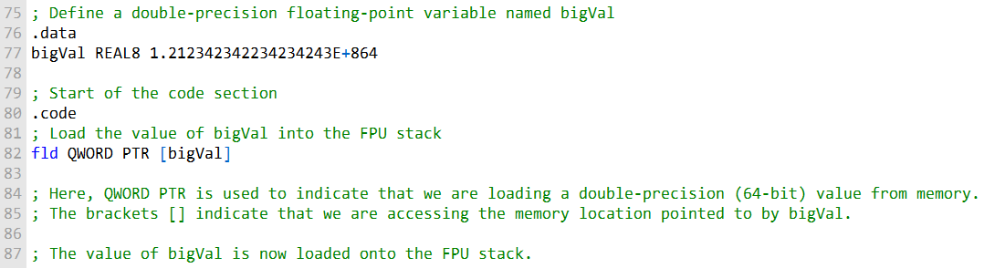

**fld instruction** loads the value of bigVal onto the FPU stack, preparing it for floating-point operations.

**bigVal** is defined as **REAL8**, so fld knows how to interpret its memory representation.

MASM supports various **floating-point data types**, which are widely used in:

* Graphics
* Scientific computing
* Financial modeling



Load Floating Point Values

This passage describes the FLD and FILD instructions.

The **FLD (load floating-point value)** instruction copies a floating-point operand to the top of the FPU stack (known as ST(0)).

The operand can be a 32-bit, 64-bit, or 80-bit memory operand (REAL4, REAL8, REAL10) or another FPU register.

The **FILD (load integer)** instruction converts a 16-, 32-, or 64-bit signed integer source operand to double-precision floating point and loads it into ST(0). The source operand's sign is **preserved.**

The following instructions load specialized constants on the stack. They have no operands:

* **FLD1:** pushes 1.0 onto the register stack.
* **FLDL2T:** pushes **log210** onto the register stack.
* **FLDL2E:** pushes **log2e** onto the register stack.
* **FLDPI:** pushes **π** onto the register stack.
* **FLDLG2:** pushes **log102** onto the register stack.
* **FLDLN2:** pushes **loge2** onto the register stack.
* **FLDZ:** pushes 0.0 on the FPU stack.

Here are some examples of how to use the FLD and FILD instructions:

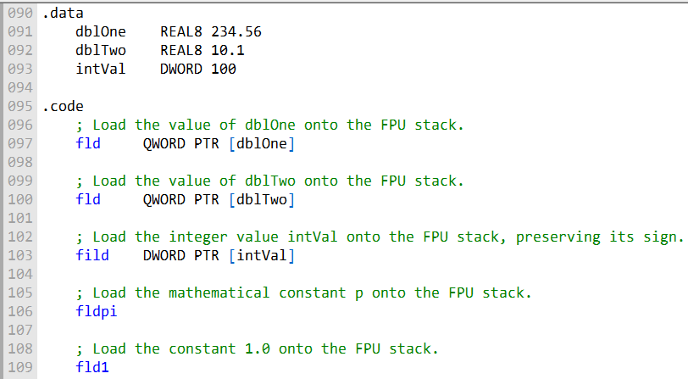

In this example, you’re working with a few variables and then loading them onto the **Floating-Point Unit (FPU) stack**:

* **dblOne** and **dblTwo**
  + Both are **double-precision floating-point variables** (64 bits each).
  + dblOne holds the value **234.56**.
  + dblTwo holds the value **10.1**.
* **intVal**
  + A **32-bit integer variable** with the value **100**.

I. Code Instructions Explained

* fld QWORD PTR [dblOne] Loads the value of dblOne (234.56) onto the FPU stack.
  + QWORD PTR tells the assembler you’re accessing a 64-bit value in memory.
  + fld is the instruction used for loading floating-point values.
* fld QWORD PTR [dblTwo] Works the same way as above, but loads dblTwo (10.1) onto the stack.
* fild DWORD PTR [intVal] This one’s different: it loads the **integer** value intVal (100) onto the FPU stack.
  + fild is specifically for loading integers.
  + It preserves the sign and automatically converts the integer into floating-point format inside the FPU.
* fldpi Loads the mathematical constant **π (pi)** onto the stack.
  + This is a predefined constant available in the FPU.
* fld1 Loads the constant **1.0** onto the stack.
  + Another predefined constant, representing the floating-point value 1.0.

II. Storing Values: FST and FSTP

Once values are on the stack, you’ll often want to store them back into memory or another register. That’s where **FST** and **FSTP** come in:

* **FST (Store Floating-Point Value)**
  + Copies the value at the top of the FPU stack (**ST(0)**) into memory or another FPU register.
  + Supports memory operand types like **REAL4**, **REAL8**, and **REAL10**.
  + Important: it **does not pop the stack**—the value stays on the stack for further use.
* **FSTP (Store and Pop)**
  + Similar to FST, but after storing the value, it **pops the stack**, removing the top element.
  + Useful when you’re done with a value and want to free up stack space.

👉 **In short:**

* fld and fild are about **loading values onto the stack**.
* fst and fstp are about **storing values back** (with or without popping).

III. FSTP (Store Floating-Point Value and Pop)

The **FSTP** instruction is like the sibling of **FST**, but with an extra step built in:

* It **copies the value in ST(0)** (the top of the FPU stack) into memory.
* Then, it **pops ST(0) off the stack**, physically removing it.
* It supports the same memory operand types as FST (**REAL4, REAL8, REAL10**) and can also store values into other FPU registers.
* By popping the stack, it updates the **TOP pointer**, which keeps track of the current stack position.

In other words, FSTP doesn’t just store—it also cleans up the stack at the same time. This makes it especially handy when you’re done with a value and want to free up space for the next calculation.

IV. Working with the FPU: Loading and Storing Values

Here’s a code example illustrating how these instructions are used:

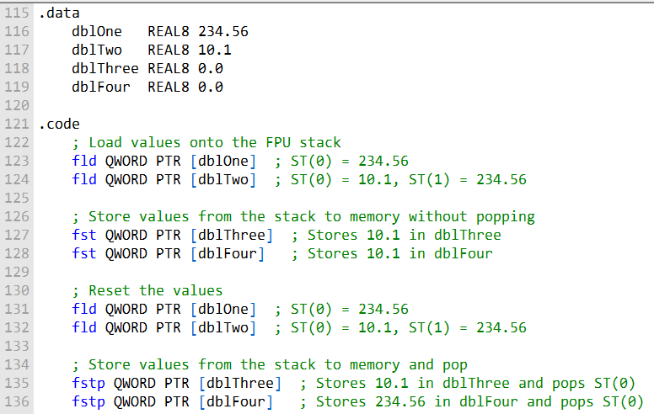

In this assembly example, you’re using the **Floating-Point Unit (FPU)** to load values onto its stack and then store them back into memory with the **FST** and **FSTP** instructions. Let’s walk through it step by step:

* **Defining the Data Variables**
  + dblOne and dblTwo are **double-precision floating-point variables** holding the values **234.56** and **10.1**, respectively.
  + dblThree and dblFour start off as **0.0** and are used later to store results from the FPU stack.
* **Loading Values with** fld
  + The fld instruction loads values onto the FPU stack.
  + First, dblOne (234.56) is loaded into **ST(0)**.
  + Then, dblTwo (10.1) is loaded into **ST(0)**, which pushes the previous value down—so now **ST(1) = 234.56**.
* **Storing with** fst
  + The fst instruction stores the value at the top of the stack (**ST(0)**) into memory **without popping it off**.
  + In this case, the value **10.1** is stored into both dblThree and dblFour.
  + The stack remains unchanged, so the values are still available for further operations.
* **Resetting for Demonstration**
  + To show the difference between fst and fstp, you reload dblOne and dblTwo onto the stack again.
* **Storing with** fstp
  + The fstp instruction stores the value from **ST(0)** into memory **and pops it off the stack** at the same time.
  + The first fstp stores **10.1** into dblThree and removes it from the stack.
  + The second fstp stores **234.56** into dblFour and pops that value too.
  + Each pop updates the stack’s **TOP pointer**, shifting the remaining values upward.

V. Key Takeaway

This example highlights the difference between the two instructions:

* **FST** → Stores the value in memory but leaves it on the stack.
* **FSTP** → Stores the value in memory and removes it from the stack.

Together, they give you flexible control over how floating-point values move between the FPU stack and memory—making them essential tools for efficient floating-point programming in assembly.

FLOATING POINT ARITHEMETIC

The arithmetic instructions in x86 assembly allow you to perform basic arithmetic operations on floating-point numbers. These instructions support the same memory operand types as **FLD (load)** and **FST (store)**, meaning operands can be **indirect**, **indexed**, **base-indexed**, and more. The key arithmetic instructions are as follows:

* **FCHS (Change Sign):** This instruction reverses the sign of the floating-point value in ST(0), effectively changing it from positive to negative or vice versa.
* **FABS (Absolute Value):** FABS clears the sign of the number in ST(0) to obtain its absolute value, effectively making it positive.
* **FADD (Add):** FADD performs addition. It can add two values from the FPU stack or add a value from memory to a value on the stack.
* **FSUB (Subtract):** FSUB subtracts the source value from the destination value.
* **FSUBR (Reverse Subtract):** FSUBR subtracts the destination value from the source value.
* **FMUL (Multiply):** FMUL multiplies the source value by the destination value.
* **FDIV (Divide):** FDIV divides the destination value by the source value.
* **FDIVR (Reverse Divide):** FDIVR divides the source value by the destination value.
* **FCHS and FABS:**
* FCHS is used to change the sign of the value in ST(0), essentially negating it if it was positive or making it positive if it was negative.
* FABS, on the other hand, computes the absolute value by clearing the sign of the value in ST(0).



FADD (Add)

The **FADD** instruction performs floating-point addition, and it can be used in different formats.

I. With no operands:

* It adds the value in **ST(0)** to **ST(1)**.
* The result is stored in **ST(1)**.
* Finally, **ST(0)** is popped off the stack, leaving the result at the top.

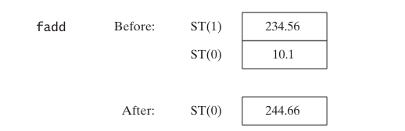

II. FADD (Add) – Other Formats

* **With a memory operand (REAL4 or REAL8)**
  + The instruction adds the value stored in memory (either a 32-bit REAL4 or a 64-bit REAL8) to the value currently in **ST(0)**.
  + The result replaces the value in **ST(0)**.
* **With a register number (ST(i))**
  + The instruction adds the value in **ST(i)** to the value in **ST(0)**.
  + Again, the result is stored back in **ST(0)**.

👉 In short: FADD can work directly with values in memory or with other registers in the FPU stack, giving you flexibility depending on where your data lives.

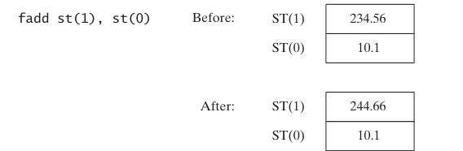

**Register Format:** FADD ST(i), ST(0)

* This version adds the value in **ST(0)** to the value in **ST(i)**.
* The result is stored in **ST(i)**, while **ST(0)** remains unchanged.
* In practice, this makes it look like the two positions have swapped roles, since ST(i) now holds the updated sum.

**Memory Operand Format**

* When FADD is used with a memory operand, it adds the value stored in memory directly to **ST(0)** (the top of the FPU stack).
* Example:
  + fadd mySingle → takes the value in the memory location mySingle and adds it to **ST(0)**.
  + The result replaces the old value in **ST(0)**, effectively increasing it by whatever was stored in mySingle.

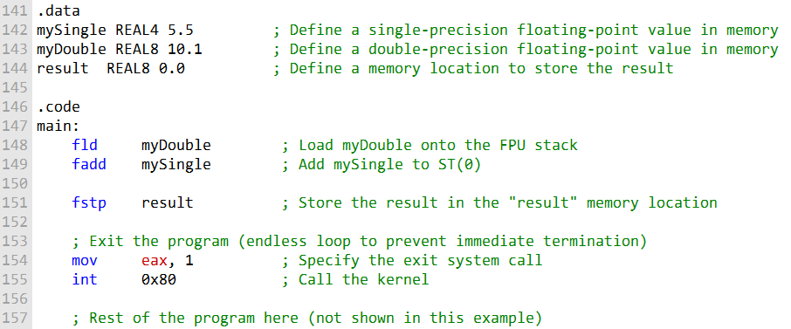

* Two floating-point values, mySingle and myDouble, are defined in memory.
* fld loads myDouble onto the FPU stack (ST(0)).
* fadd adds mySingle to the value in ST(0).
* fstp stores the result into the memory location result.
* The program then exits.

**Notes:**

* The code assumes a **Linux environment** (uses int 0x80 system call).
* Adjust system calls and assembly syntax for **other OSes or assemblers** as needed

III. FADDP (Add with Pop)

**FADDP (“Add with Pop”)**: Performs addition and then **pops ST(0)** from the FPU stack.

**Purpose:** Helps efficiently **manage the FPU stack** during calculations.

**Syntax:** FADDP ST(1), ST(0)

* Adds ST(0) to ST(1).
* Stores the result in ST(1).
* Removes ST(0) from the stack.

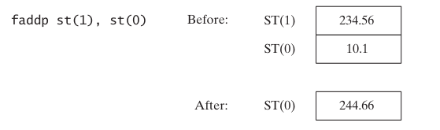

IV. FIADD (Add Integer)

**FIADD**: Adds an **integer value** to ST(0) after converting it to **double-extended precision floating-point**.

**Supported operand types:**

* m16int → 16-bit integer
* m32int → 32-bit integer

**Example:** fiadd myInteger

* Converts the integer at myInteger to floating-point
* Adds it to the value in ST(0)

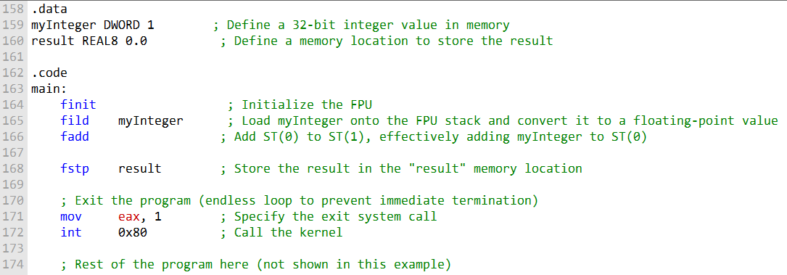

In this code:

* Define an **integer value** myInteger in memory and a memory location result to store the result.
* Use finit to **initialize the FPU**.
* Load myInteger onto the FPU stack and **convert it to floating-point** using fild.
* Use fadd to **add the value in ST(0) to ST(1)** (effectively adding myInteger to the existing floating-point value).
* Store the **result** in memory using fstp into result.

**Note:**

* Uses int 0x80 system call for Linux.
* Adjust system calls and assembly syntax for **Windows or other platforms**.

V. FSUB (Floating-Point Subtract)

* **Purpose:** Subtracts a **source operand** from a **destination operand** in the FPU.
* **Destination:** Always ST(0) (top of stack).
* **Source:** Can be an **FPU register** or **memory operand** (same types as FADD).
* **Operation:** Similar to FADD, but performs **subtraction**.

**Usage without operands:**

* Subtracts ST(0) from ST(1).
* Result is stored in ST(1).
* ST(0) is **popped**, leaving the result on top.

**Examples:**

* fsub mySingle → ST(0) -= mySingle
* fsub array[edi*8] → subtracts value from memory from ST(0) (stack not popped)

VI. FSUBP (Floating-Point Subtract with Pop)

* **Purpose:** Performs subtraction **and pops ST(0)** from the stack.
* After execution:
  + Result is left in **ST(0)**
  + Stack pointer is **adjusted** accordingly

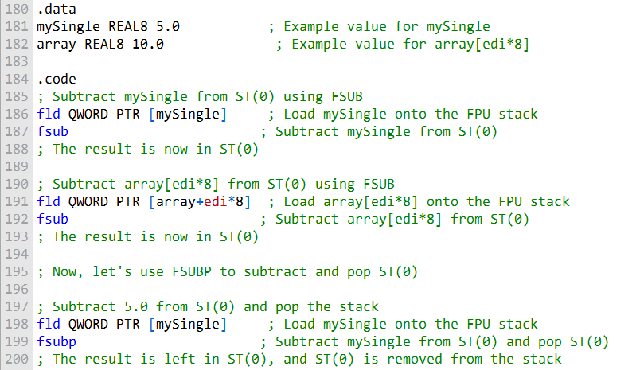

**Example: FSUBP**

* fsubp ST(1), ST(0)
  + Subtracts ST(0) from ST(1).
  + Leaves the **result in ST(0)**.
  + Pops the **old ST(0)** from the stack.

VII. FISUB (Floating-Point Subtract Integer)

* Subtracts an **integer** from the value in ST(0).
* Converts the **integer source operand** to **double-extended precision floating-point** before subtraction.
* Enables **arithmetic between integers and floating-point numbers** in the FPU.

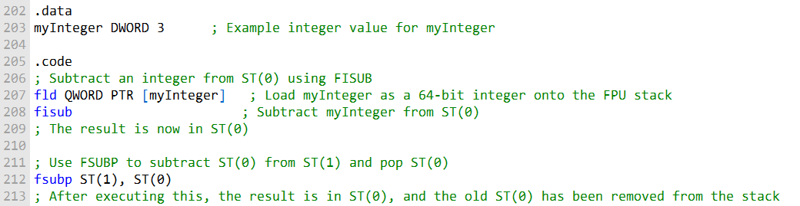

FISUB and FSUBP Examples

FISUB (Floating-Point Subtract Integer):

* Subtracts an **integer** from ST(0) after converting it to **double-extended precision floating-point**.
* Examples:
  + fisub m16int → subtracts a **16-bit integer** from ST(0).
  + fisub m32int → subtracts a **32-bit integer** from ST(0).

FSUBP (Floating-Point Subtract with Pop):

* fsubp ST(1), ST(0)
  + Subtracts ST(0) from ST(1).
  + Stores the **result in ST(0)**.
  + Pops the **old ST(0)** from the stack.

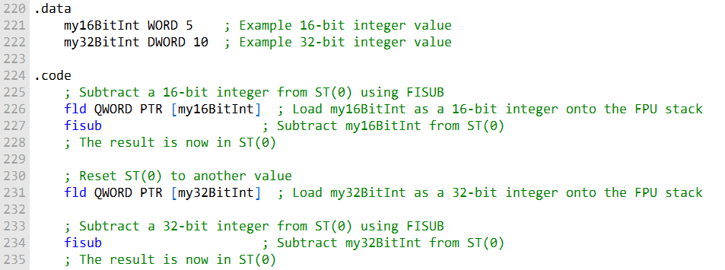

These code examples demonstrate how to use FISUB to subtract 16-bit and 32-bit integers from an FPU register after converting them to floating-point format.

This provides flexibility for performing arithmetic operations with different data types and operands in floating-point arithmetic.

VIII. FMUL (Floating-Point Multiply)

* **Purpose:** Multiplies a **source operand** by a **destination operand** (always an FPU register).
* **Source operand:** Can be an **FPU register** or **memory operand** (like FADD/FSUB).

**FMUL usage:**

* **No operands:**
  + Multiplies ST(0) by ST(1).
  + Result temporarily stored in ST(1).
  + ST(0) is **popped**, leaving the product in ST(0).
* **With memory operand:**
  + Multiplies ST(0) by the value in memory.

**FMULP (Floating-Point Multiply with Pop):**

* Similar to FMUL, but **pops ST(0)** after multiplication.
* Result is left in ST(0); stack pointer is adjusted.

**FIMUL (Floating-Point Integer Multiply):**

* Works like FIADD, but performs **multiplication** instead of addition.
* Converts **integer source operand** to **double-extended precision floating-point** before multiplying.

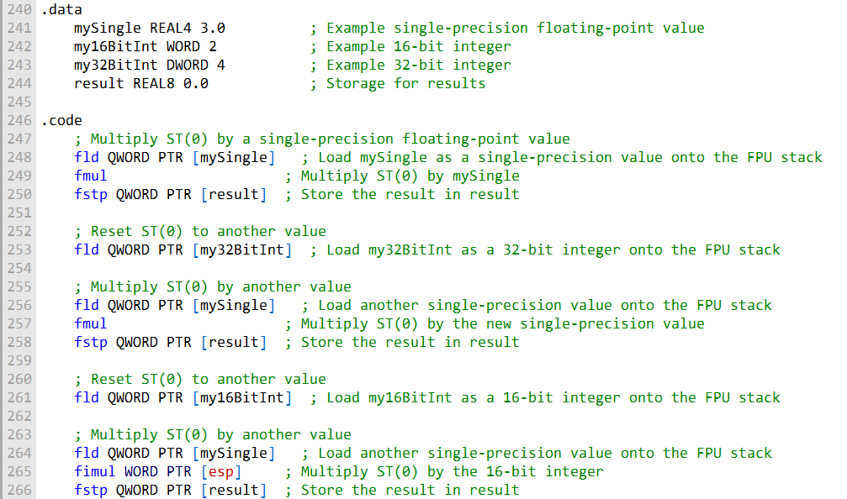

**Variable Initialization:**

.data section defines variables:

* mySingle → single-precision float (3.0)
* my16BitInt → 16-bit integer (2)
* my32BitInt → 32-bit integer (4)
* result → stores results of multiplications

**Single-Precision Floating-Point Multiplication:**

* fld mySingle → loads mySingle onto FPU stack (ST(0)).
* fmul → multiplies ST(0) by itself.
* fstp result → stores the result in memory (result).

**Resetting the FPU Stack:**

* fld my32BitInt → loads a new value onto ST(0) for the next multiplication.

**Second Single-Precision Multiplication:**

* fld → loads another single-precision value into ST(0).
* fmul → multiplies the value in ST(0) by the new single-precision value.
* fstp result → stores the result in memory.

**Resetting FPU Stack Again:** fld my16BitInt → prepares stack for integer multiplication.

**Integer Multiplication with FIMUL:**

* fld → loads a 16-bit integer onto ST(0).
* fld → loads a single-precision float onto ST(0).
* fimul WORD PTR [esp] → multiplies the integer in ST(0) with the float.
* fstp result → stores the result in memory.

**Completion:**

* Result of integer multiplication is stored in result.
* Demonstrates **different multiplication scenarios** in x86 FPU:
  + Floating-point × floating-point
  + Integer × floating-point
  + Using fld, fmul, fimul, and fstp for stack management and result storage

IX. FDIV (Floating-Point Division)

* **Purpose:** Divides the **destination operand** by the **source operand**, result stored in the destination.
* **Operands:**
  + Destination → must be an **FPU register** (ST(0)).
  + Source → can be an **FPU register** or **memory operand**.
* **Syntax examples:**
  + fdiv ST(0), ST(i) → divides ST(i) by ST(0)
  + fdiv m64fp → divides ST(0) by a 64-bit float in memory
* **Special cases:**
  + Division by **zero** → divide-by-zero exception
  + Division by **infinity**, **zero**, or **NaN** → handled according to Intel rules

X. FIDIV (Floating-Point Divide Integer)

* **Purpose:** Performs division of an **integer by a floating-point value** in ST(0).
* **Conversion:** Source integer is converted to **double-extended precision floating-point** before division.
* **Supported integer types:**
  + m16int → 16-bit integer
  + m32int → 32-bit integer
* **Use case:** Enables **mixed integer and floating-point arithmetic** in the FPU.
* **Code examples:** Can demonstrate division with:
  + FPU registers
  + Memory operands
  + Mixed integer/floating-point operands

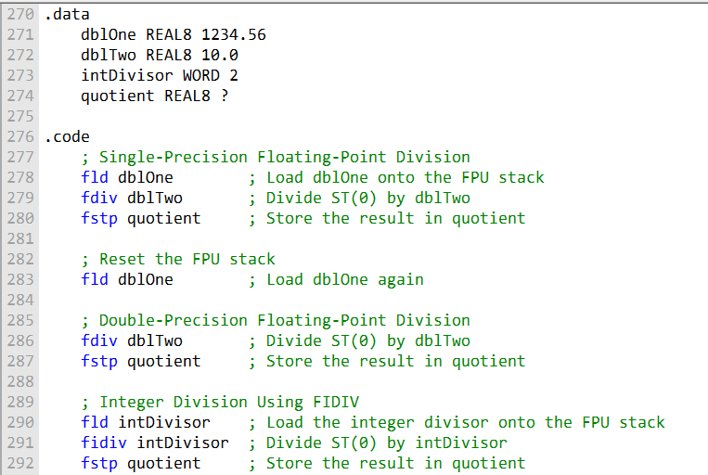

**Variable Initialization (.data section):**

* dblOne → double-precision float (first dividend)
* dblTwo → double-precision float (divisor)
* intDivisor → integer divisor
* quotient → stores the results of division operations

**Single-Precision Floating-Point Division:**

* fld dblOne → loads dblOne onto the FPU stack (ST(0))
* fdiv dblTwo → divides ST(0) by dblTwo
* fstp quotient → stores the result in memory

**Double-Precision Floating-Point Division:**

* fld dblOne → reloads dblOne onto the stack
* fdiv dblTwo → divides ST(0) by dblTwo with double precision
* fstp quotient → stores the result

**Integer Division with FIDIV:**

* fld intDivisor → loads the integer onto the FPU stack
* fidiv → divides ST(0) by the integer (converted to floating-point)
* fstp quotient → stores the result

**Summary:**

* Demonstrates **various division scenarios** in the x86 FPU:
  + Single-precision floating-point division
  + Double-precision floating-point division
  + Integer division
* Results are consistently stored in the **quotient variable**
* Provides a **comprehensive example** of FPU division operations in assembly language

COMPARING FLOATING-POINT VALUES

* **FCOM (Floating-Point Compare):**
  + Compares ST(0) (top of FPU stack) to a **source operand** (memory or FPU register).
* **FNSTSW (Store FPU Status Word):**
  + Moves the **FPU status word** into AX.
  + Status word contains **condition codes** indicating the comparison result (greater, less, equal, unordered).
* **SAHF (Store AH into Flags):**
  + Copies AH (upper byte of AX) into **EFLAGS** register.
  + EFLAGS now has the CPU **Zero, Parity, Carry, and Sign flags** reflecting the comparison.
* **Conditional Jumps:**
  + Use CPU flags from EFLAGS to **branch** based on comparison.
  + Example: branch to greater_than if ST(0) > ST(1).

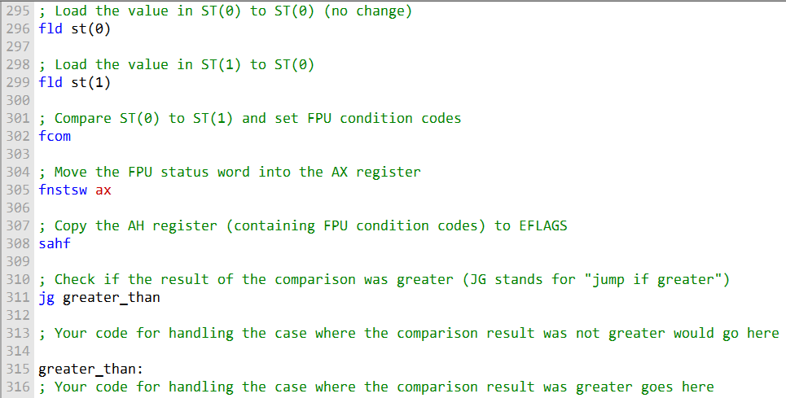

* **greater_than label:**
  + Marks the location to continue execution if ST(0) > ST(1).
* **Handling the "not greater" case:**
  + Place code in a designated section for when the comparison result is **≤**.
* **Code sequence:**
* **Load values** onto the FPU stack (ST(0) and ST(1)).
* **FCOM** → compares ST(0) with the source operand (ST(1) or memory).
* **FNSTSW AX** → moves FPU status word into AX (contains condition codes).
* **SAHF** → copies relevant bits from AH into **EFLAGS**.
* **JG greater_than** → jumps to greater_than if comparison result indicates ST(0) > ST(1).
* **Summary:**
  + This sequence enables **floating-point comparisons** to control program flow.
  + It bridges **FPU status codes** to **CPU conditional jumps**.

The following table shows the condition codes and the corresponding conditional jump instructions:

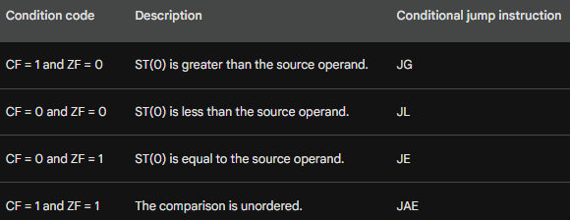

Floating-Point Comparisons (Handling NaN & Unordered Cases)

**Unordered comparison:**

* Occurs if **either operand is NaN**.
* Also occurs if **operands have different signs** and **one is zero**.

**Importance:**

* Comparing floating-point values and branching is critical for:
  + Graphics
  + Scientific computing
  + Financial modeling

FCOMI Instruction

**Purpose:**

* Compares two floating-point values **directly**.
* Sets **CPU flags** (Zero, Parity, Carry) based on comparison.

**Advantages over FCOM + FNSTSW + SAHF:**

* Eliminates the need to:
  + Store FPU status word in AX
  + Copy AH into EFLAGS
* Flags are set **directly**, simplifying branching logic.

**Usage:**

* Pass the two floating-point values as operands.
* CPU flags reflect comparison:
  + **ZF** → Zero flag (ST(0) = ST(i))
  + **PF** → Parity flag (unordered, e.g., NaN)
  + **CF** → Carry flag (ST(0) < ST(i))

**Summary:**

* FCOMI is **modern and efficient** for floating-point comparisons on Pentium-class (P6) and later processors.
* Useful for **conditional branching** without extra instructions.

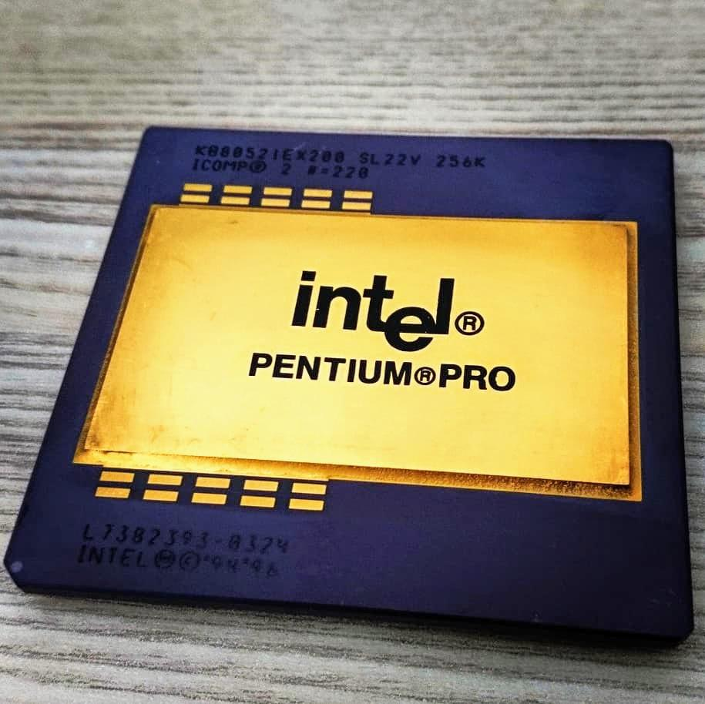

Unordered Condition in FPU Comparisons

The following table shows the condition codes set by the FCOMI instruction:

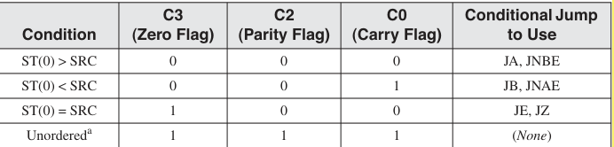

An unordered condition occurs in floating-point comparisons when either operand is a NaN, or when the operands have different signs and one of them is zero.

In this case, the condition codes are set to **111**, meaning all three flags (CF, ZF, and PF) are equal to 1.

There is no standard conditional jump instruction that directly corresponds to this code.

After using the **FCOMI** instruction, conditional jumps can only be applied if the comparison result is ordered.

If the result is unordered, special handling is required—for example, checking the **PF flag** to detect the presence of a NaN.

For example, the following code branches to the L1 label if the value in ST(0) is less than the value in ST(1):

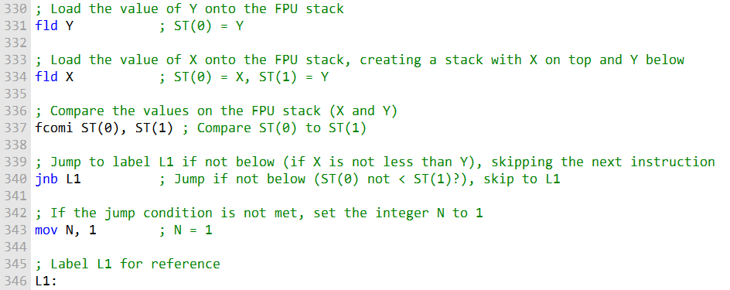

**fld Y** – This instruction grabs the value of Y (our second floating-point number) and puts it on the FPU stack. After this, ST(0) holds Y.

**fld X** – Next, we load X (the first floating-point number) onto the stack. This pushes Y down to ST(1) and puts X on top at ST(0). Now our stack is ready for a comparison.

**fcomi ST(0), ST(1)** – Here’s where the magic happens! This instruction compares X (ST(0)) with Y (ST(1)). If X is **not less than** Y, it sets the carry flag (CF) to 1.

**jnb L1** – This checks that carry flag. “Jump if not below” basically means: if X is **not less than** Y, skip the next instruction and go straight to label L1.

**mov N, 1** – If the comparison shows that X **is less than** Y, this instruction sets the integer N to 1. So N becomes 1 only when the condition is true.

**L1:** – This is just a marker in the code. It marks the end of this little conditional block so the program knows where to continue.

**In short:** This snippet compares two floating-point numbers, X and Y, and sets N to 1 if X is smaller than Y. It’s a neat example of using the FPU’s condition codes—especially the carry flag—to make decisions in your program.

FCOM Instruction

FCOM is an instruction that compares two floating-point numbers on the FPU stack and updates the condition flags based on the outcome.

Here’s a simple example: we have two double-precision numbers, X and Y, and we want to compare them. If X is **less than** Y, we’ll set an integer N to 1. It’s a neat way to use the FPU to make decisions in your code!

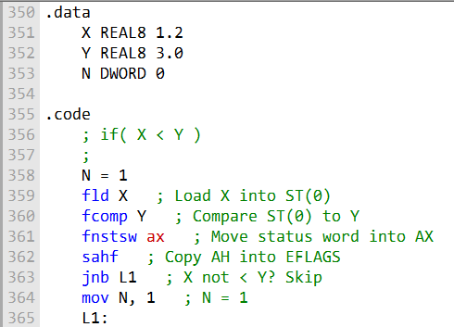

This code snippet shows how **FPU condition codes** are set and how **conditional jumps** control program flow based on comparison results.

A useful improvement is using the **FCOMI instruction**, which is available on newer processors like the Intel P6 family (Pentium Pro, Pentium II).



**FCOMI** is more efficient because it **directly compares two values** on the FPU stack and sets the condition flags, making comparisons faster than FCOM.

With FCOMI, you can perform floating-point comparisons and **set the Zero, Parity, and Carry flags** directly.

Here’s an example of performing the same comparison using **FCOMI**.

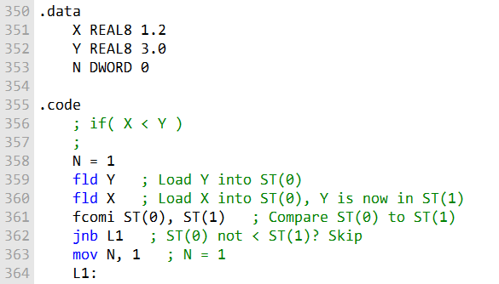

Comparing For Equality

**Comparing for equality** in assembly means checking if two floating-point values are “close enough” rather than exactly equal.

The standard approach is to compute the **absolute difference**, |x - y|, and see if it’s smaller than a tiny number called **epsilon**.

Why? Because **floating-point numbers are approximate**, and tiny rounding errors can make direct comparisons unreliable.

The following assembly code shows how to compare two values, val2 and val3, using a tolerance of **epsilon**.

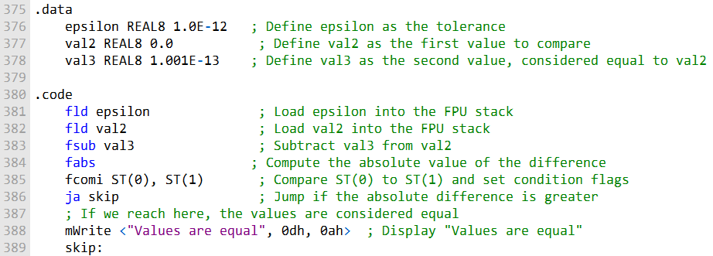

This assembly code compares two floating-point values, val2 and val3, for equality **within a small tolerance** called epsilon.

**Why?** Floating-point numbers aren’t exact due to precision limits, so direct comparisons can fail. Using a tolerance ensures “close enough” values are treated as equal.

**Data Section (.data):**

* epsilon = 1.0E-12 → the maximum difference allowed to consider two values equal.
* val2 = 0.0 → first value to compare.
* val3 = 1.001E-13 → second value, slightly different from val2.

**Code Section (.code):**

* fld epsilon → loads the tolerance onto the FPU stack.
* fld val2 → loads the first value (val2).
* fsub val3 → subtracts val3 from val2 to get the difference.
* fabs → converts the difference to its absolute value.
* fcomi ST(0), ST(1) → compares the absolute difference with epsilon and sets condition flags.
* ja skip → jumps to skip if the difference is greater than epsilon (values are **not equal**).
* mWrite <"Values are equal", 0dh, 0ah> → prints a message if the difference is within the tolerance.
* skip: → label to continue execution when the values are not equal.

**Summary:**

* This snippet shows a safe way to compare floating-point numbers, accounting for rounding errors.
* Using epsilon makes the comparison robust for real-world calculations.

FLOATING-POINT INPUT/OUTPUT PROCEDURES

Assembly doesn’t have “nice” built-in input/output like high-level languages, so special procedures are used to handle floating-point numbers. Two key ones are:

* **ReadFloat**
  + Reads a floating-point value typed in from the keyboard.
  + Pushes that value directly onto the **FPU stack**.
  + It’s flexible — it understands lots of formats, like:
    - 35
    - +35.
    - -3.5
    - .35
    - 3.5E5 or 3.5E005
    - -3.5E+5
    - 3.5E-4 or +3.5E-4
* **WriteFloat**
  + Takes the floating-point value at the top of the FPU stack (**ST(0)**).
  + Prints it to the console in **exponential format** (scientific notation).

What the Example Program Does

The demo program ties these procedures together:

1. Pushes two floating-point values onto the FPU stack.
2. Displays the current contents of the stack.
3. Asks the user to type in two floating-point numbers.
4. Multiplies those two numbers together.
5. Displays the product back to the console using WriteFloat.

👉 So in short: **ReadFloat** is your input tool, **WriteFloat** is your output tool, and the program shows how to use them with the FPU stack to do actual math.

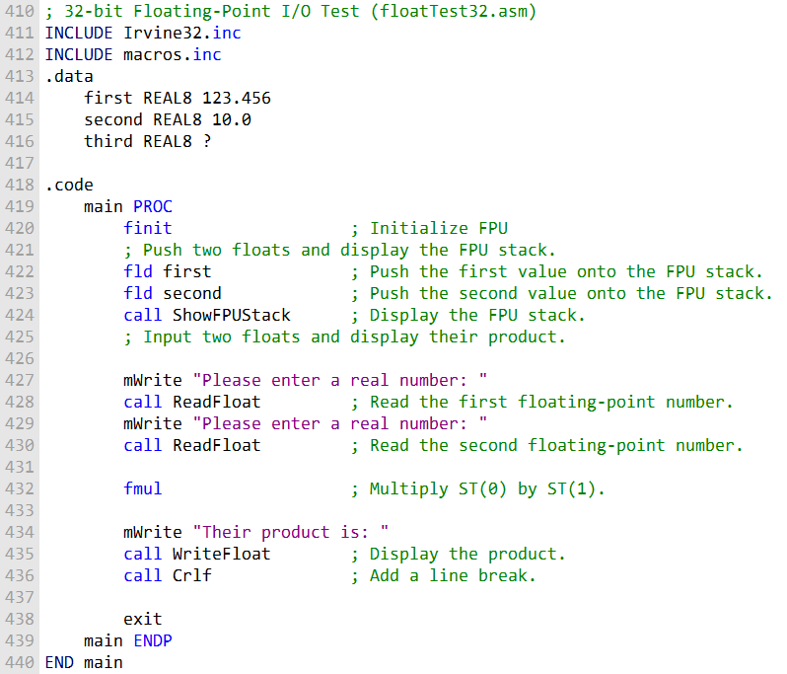

**What the Program Really Does**

1. **Initialize the FPU** → Get the floating-point unit ready.
2. **Load values** → Push two numbers onto the FPU stack.
3. **Show the stack** → Display what’s currently inside the stack.
4. **Take user input** → Ask for two floating-point numbers and push them onto the stack.
5. **Multiply** → Use fmul to multiply the two numbers.
6. **Display result** → Print “Their product is:” followed by the result in exponential format.
7. **Exit cleanly** → Add a line break and finish.

👉 So in one line: **The program reads two floating-point numbers, multiplies them using the FPU, and prints the result.**

EXCEPTION SYNCHRONIZATION

In concurrent systems, multiple tasks can run at the same time. This creates a special challenge for **floating-point exceptions**, because the **CPU** and the **FPU (Floating-Point Unit)** operate as separate units.

* **The Problem** - If an unmasked floating-point exception occurs while the CPU is busy executing an integer or system instruction, the exception won’t be handled right away. Instead, it will only be processed when the next floating-point instruction runs—or when a **WAIT/FWAIT** instruction is explicitly used.
* **Why This Matters** - This delay can cause trouble if the floating-point instruction that triggered the exception is immediately followed by an integer or system instruction that modifies the same memory operand. In that case, the CPU might change memory before the floating-point exception is even recognized, leading to inconsistent or incorrect results.
* **Example Scenario -** Imagine code where a floating-point operation causes an exception, but the very next instruction is an integer operation that writes to the same memory location. Without synchronization, the exception handling gets delayed, and the memory update happens first—creating a conflict.

👉 The **WAIT** and **FWAIT** instructions are the solution here. They force the CPU to pause until the FPU has finished its work and any pending exceptions are handled, ensuring proper synchronization between the two units.

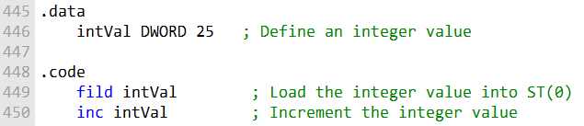

This code **loads an integer value (intVal) onto the FPU stack** (ST(0)) using the FILD instruction and then **increments the original integer in memory** with INC.

Important note: INC changes the value in memory, not the value on the FPU stack.

If an **unmasked floating-point exception** occurs during FILD, it won’t be handled until INC runs. This can cause problems if INC modifies the same memory location—then the exception handler might see the wrong value.

To fix this, you can use **WAIT or FWAIT**:

* These instructions **pause execution until any pending floating-point exceptions are handled**.
* This ensures the exception handler gets a chance to run **before any other instructions modify the memory operand**.

In practice, you’d insert a WAIT or FWAIT **right after FILD**, so the FPU exception is handled before the INC instruction.

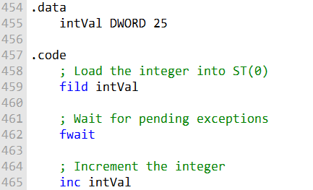

In this version, FILD loads the integer value into the **FPU stack**.

FWAIT comes next, making sure any **pending floating-point exceptions** are handled before moving on.

INC then increments the integer in memory.

This sequence ensures the **exception handler gets a chance to run** before the memory value is modified, keeping everything safe and predictable.

Example Code For FPU Operations:

Here's the code for the expression **valD = -valA + (valB * valC)**

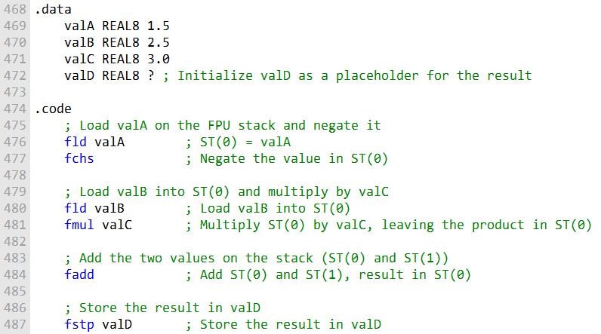

This code calculates valD using the expression **-valA + (valB * valC)**.

First, valA is loaded onto the FPU stack and **negated** with fchs.

Next, valB is loaded onto the stack and **multiplied by valC**, leaving the product in ST(0).

The two values on the stack are **added together**.

Finally, fstp **stores the result in valD** and **removes it from the stack**.

Sum Of Array Of Double Precision Numbers

In the code below, you are calculating the sum of an array of double-precision real numbers.

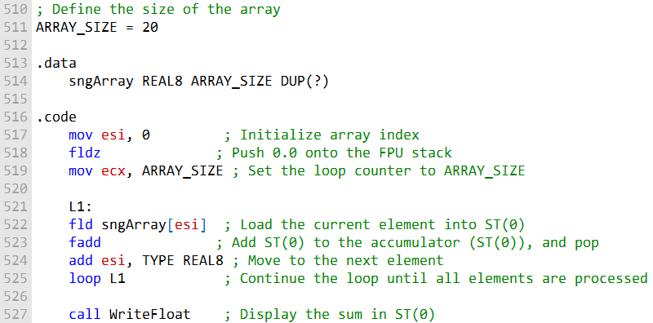

This code calculates and displays the sum of a double-precision array.

The array size is defined by the constant ARRAY_SIZE = 20, making it easy to adjust the array length in one place.

We start by initializing a loop counter (esi = 0) and pushing 0.0 onto the FPU stack (fldz) to serve as our sum accumulator.

Another counter, ecx, is set to ARRAY_SIZE to control the loop.

The loop (L1) does the following for each array element:

Load the current element with fld sngArray[esi].

Add it to the accumulator using fadd, which also pops the value from the stack.

Move to the next element with add esi, TYPE REAL8 (8 bytes per double).

The loop repeats until all elements are processed.

After the loop, WriteFloat is called to display the sum stored in ST(0).

Calculating The Sum Of Squares Of Two Numbers

In this code, we are calculating the sum of the square roots of two numbers, valA and valB. Here are the steps involved:

We define two real numbers, valA and valB, which have the values 25.0 and 36.0, respectively.

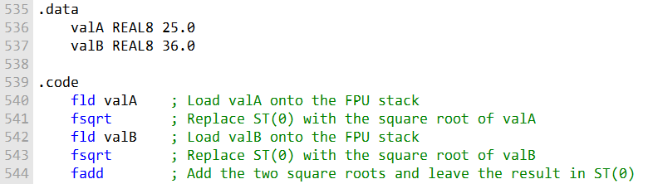

This code calculates the **sum of the square roots** of valA and valB using FPU instructions.

**Step by step:**

* fld valA → loads valA onto the FPU stack (ST(0)).
* fsqrt → replaces ST(0) with the **square root of valA**.
* fld valB → loads valB onto the stack (ST(0)).
* fsqrt → computes the **square root of valB**.
* fadd → adds the two square roots, leaving the **sum in ST(0)**.

In short, the FPU stack is used efficiently to **load values, compute square roots, and add them**, giving the final result in ST(0).

Calculating The Dot Product Of Two Pairs Of Numbers

Here, you have a code snippet that calculates the dot product of two pairs of numbers from an array. The input data contains two pairs of numbers stored in the "array" variable.

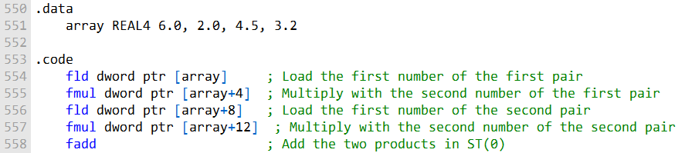

This code calculates the dot product of two pairs of numbers from the array.

It multiplies each pair of elements together and then adds the results.

The final value, stored in ST(O) , is the sum of the products, giving the dot product.

MIXED-MODE ARITHMETIC

Mixed-mode arithmetic is just a fancy way of saying arithmetic that mixes **integers** and **real numbers** (floating-point numbers).

In assembly language, the Intel instruction set has some handy instructions that help with this. Basically, it can **promote integers to reals** and put them on the floating-point stack so you can do your calculations without any fuss.

Step 1: Promote an integer to a real  
Before you can do arithmetic with a real number, you need to convert your integer. For example:



This instruction takes the integer in the N register, turns it into a real, and loads it onto the floating-point stack. Easy, right?

Step 2: Do your arithmetic  
Once your number is on the floating-point stack, you can do all your floating-point operations just like normal.

Step 3: Store the result back as an integer  
After you’re done with the arithmetic, you might want to store the result as an integer. That’s where FIST comes in:

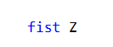

This stores the real number in ST(0) back into the integer variable Z. One important thing to remember: FIST **rounds to the nearest integer**.

If you want to **truncate** instead of round, there’s a way to do that too (we’ll get into the code for that next).

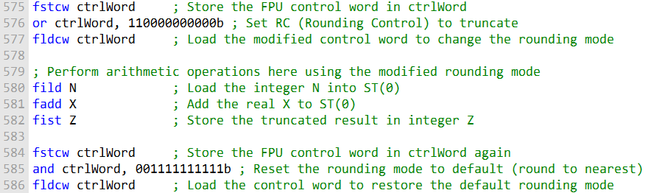

* Store the FPU control word in the variable ctrlWord.
* Modify the RC field in ctrlWord to set the rounding mode to **truncate**.
* Perform the desired arithmetic operations.
* Store the FPU control word again.
* Reset the rounding mode to the default (**round to nearest**) by using a **bitwise AND** to clear the rounding mode bits.
* Load the modified control word to ensure the default rounding mode is restored.

Example 1: Adding an Integer to a Double

In this example, you're adding an integer (N) to a double (X) and storing the result in a double (Z).

The C++ code automatically promotes the integer to a real before performing the addition. The equivalent assembly code for this operation is as follows:

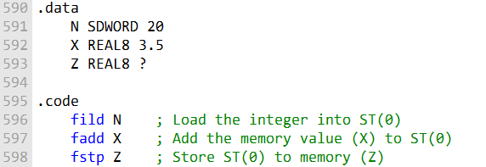

This code loads the integer N into ST(0), adds the real value X, and stores the result in the real Z.

Example 2: Promoting and Truncating

In this example, you're promoting an integer (N) to a double and evaluating a real expression involving N and X.

The result is stored in an integer (Z). C++ typically performs the conversion automatically, but in assembly, you use FIST to convert the result to an integer. Here's the code:

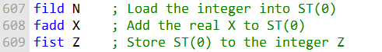

This code loads the integer N into ST(0), adds the real X, and then stores the truncated result in the integer Z.

Changing the Rounding Mode

The FPU (Floating-Point Unit) has a control word, and the **RC field** in this control word lets you choose how numbers get rounded.

Here’s how it works:

* Use **FSTCW** to store the current control word in a variable.
* Change the **RC field** in that variable to pick your rounding mode—like **truncate** or **round to nearest**.
* Use **FLDCW** to load your modified control word back into the FPU.

Once you do this, all floating-point operations will follow the rounding mode you set. It’s a neat way to control exactly how your numbers are rounded!

**Example 3:**

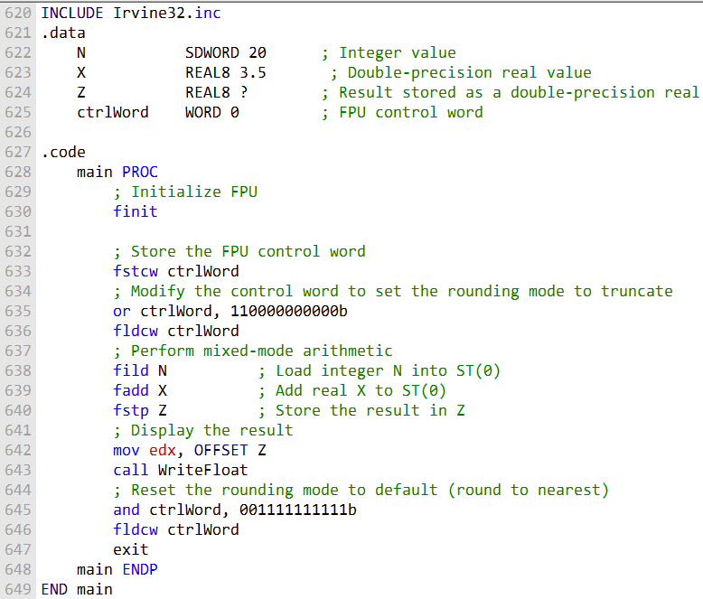

**Initialization:**

* Include Irvine32.inc for handy I/O and utility functions.
* Define variables:
  + N SDWORD 20 — signed integer 20
  + X REAL8 3.5 — double-precision real 3.5
  + Z REAL8 ? — double-precision real to store the result
  + ctrlWord WORD 0 — stores the FPU control word

**FPU Setup:**

* finit — initializes the FPU for a clean start
* fstcw ctrlWord — save the current FPU control word for modification

**Rounding Mode:**

* or ctrlWord, 110000000000b — sets FPU rounding to **truncate**
* Perform mixed-mode arithmetic:
  + fild N — load integer as real
  + fadd X — add double-precision real
  + fstp Z — store result in Z

**Displaying the Result:**

* Prepare Z for output and call WriteFloat

**Resetting Rounding Mode and exit:**

* and ctrlWord, 001111111111b — restore default rounding (round to nearest)
* Program Exit

**Summary of What This Program Demonstrates:**

* Modifying the FPU control word to change rounding modes
* Performing mixed-mode arithmetic between integers and double-precision reals
* Controlling rounding behavior to ensure predictable results
* Displaying the calculated result and then restoring the FPU to default settings

UNMASKING FLOATING-POINT EXCEPTIONS

Masking and Unmasking Floating-Point Exceptions

* By default, **floating-point exceptions are masked** — the processor handles them automatically and keeps running.
* To **unmask** an exception, you clear the corresponding bit in the FPU control word.
* Example: clearing the right bit will unmask the **divide-by-zero** exception, allowing the processor to signal it instead of using a default result.

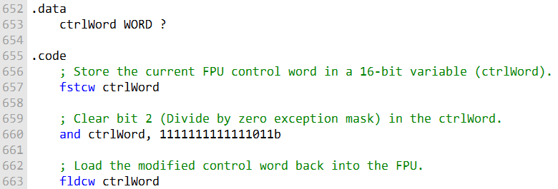

**Unmasking the Divide-by-Zero Exception**

* Store the current FPU control word in ctrlWord.
* Clear **bit 2** to unmask the divide-by-zero exception.
* Load the modified control word back into the FPU.
* After this, any divide-by-zero triggers the processor to run an exception handler.
* If no handler is installed, the processor shows an error and terminates the program.

Here is an example of code that divides by zero and generates an unmasked exception:

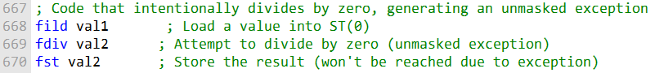

**Triggering an Unmasked Divide-by-Zero Exception**

* Load val1 into the FPU stack with fild.
* Attempt to divide by val2 using fdiv. Since val2 is zero, this triggers the **unmasked divide-by-zero exception**.
* The following fst val2 won’t execute because the exception stops normal flow.
* The system displays a **Floating-Point Division by Zero** error, giving options to retry or terminate.

The program will trigger a system dialog indicating "Floating-Point Division by Zero," giving the user the option to retry or terminate the program.

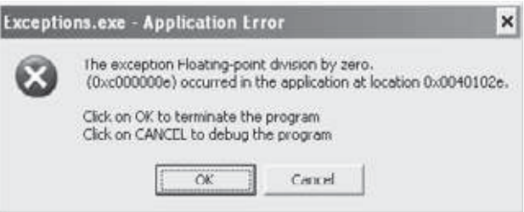

* Write an instruction that loads a duplicate of ST(0) onto the FPU stack.
* If ST(0) is positioned at absolute register R6 in the register stack, what is the position of ST(2)?
* Name at least three FPU special-purpose registers.
* When the second letter of a floating-point instruction is B, what type of operand is indicated?
* Which floating-point instructions accept immediate operands?
* How do you promote an integer in memory to a floating-point value on the FPU stack?
* Which instruction stores a floating-point value from ST(0) to memory as an integer?
* How can you change the FPU rounding mode to truncate?
* How do you restore the FPU rounding mode to round-to-nearest after changing it?
* How do you mask or unmask a floating-point exception?
* Which FPU control word bit is cleared to unmask the divide-by-zero exception?
* What happens if an unmasked divide-by-zero exception occurs and no handler is installed?
* Which instruction initializes the FPU for a clean start?
* How would you perform a mixed-mode addition between an integer and a double-precision real?
* Which instruction stores the FPU control word into a memory variable?
* Which instruction loads a modified control word back into the FPU?
* What is the effect of the fadd instruction when used after fild?
* What does the fstp instruction do to the FPU stack?
* What is the top-of-stack register in the FPU called?
* Which instructions are used to load common constants like +1.0, 0.0, or π onto the FPU stack?

X86 INSTRUCTION FORMAT

The passage you sent describes the general x86 machine instruction format and its components.

The general x86 machine instruction format contains the following fields:

* **Instruction prefix byte:** Overrides default operand sizes.
* **Opcode (operation code):** Identifies a specific variant of an instruction.
* **Mod R/M field:** Identifies the addressing mode and operands.
* **Scale index byte (SIB):** Used to calculate offsets of array indexes.
* **Address displacement field:** Holds an operand's offset, or it can be added to base and index registers in addressing modes such as base-displacement or base-index-displacement.
* **Immediate data field:** Holds constant operands.

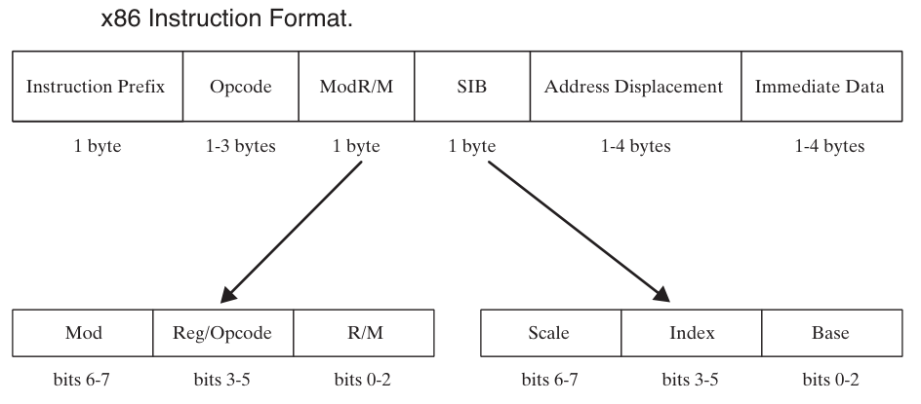

**Instruction prefix byte**

* Single byte used to override default operand sizes
* Example: REX prefix changes operand size from 16-bit to 32-bit

**Opcode**

* Single or multiple bytes that identify a specific instruction variant
* Example: ADD instruction opcode is 01

**Mod R/M field**

* Single byte that specifies addressing mode and operands
* First 2 bits indicate addressing mode
* Remaining bits specify operands

**Scale Index Byte (SIB)**

* Single byte used to calculate array index offsets
* Works with base and index registers to determine effective address

**Address displacement field**

* Single or multiple bytes holding an operand’s offset
* Can be added to base and index registers in base-displacement or base-index-displacement modes

**Immediate data field**

* Single or multiple bytes holding constant operands
* Used in instructions like MOV and ADD

**Notes**

* Not all instructions include all fields (e.g., ADD only has opcode and Mod R/M)
* Understanding these fields is important for writing assembly code

**MOD field**

* Two bits in the Mod R/M field specifying the addressing mode for the operand
* Values define which addressing mode is being used

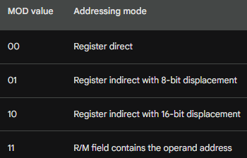

**Mod Field Values in x86 Instruction Encoding**

* **Mod 00:**
  + Displacement = 0
  + No disp-low or disp-high bytes, **except** if R/M = 110 → 32-bit displacement is used
  + Used for memory addressing with no offset
* **Mod 01:**
  + Displacement = disp-low byte, sign-extended to 16 bits
  + No disp-high byte
  + Used when a small (8-bit) displacement is needed
* **Mod 10:**
  + Displacement = disp-high and disp-low bytes used
  + Full 32-bit displacement included
  + Used when a large displacement is needed
* **Mod 11:**
  + R/M field contains a **register number**, not memory address
  + No displacement is used
  + Operand is directly in a register

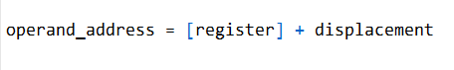

where [register] is the value of the register specified by the R/M field, and displacement is the displacement value specified in the instruction.

* **Operand Address Calculation (if Mod ≠ 11):**
  + operand_address = [register] + displacement
  + [register] = value of register specified by R/M
  + displacement = value specified in instruction

**Purpose:** These modes control **how memory operands are addressed** and whether a displacement is included in the instruction encoding

Here are some examples of how the MOD field is used to specify the addressing mode for the operand in the Mod R/M field:

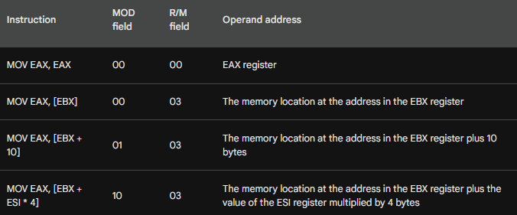

Then…

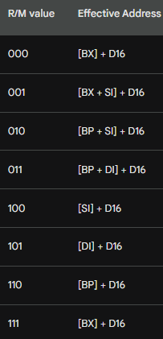

I. The ModR/M Byte Structure

The **ModR/M byte** is made up of several parts, and the R/M field is not a full byte by itself; it is a **3-bit sub-field** within the 8-bit ModR/M byte.

The ModR/M byte is structured as follows: **Mod** (bits 7-6) indicates the addressing mode, such as 10 for a 16-bit displacement.

The **Reg/Opcode** field (bits 5-3) usually specifies a register or provides additional opcode information.

The **R/M** field (bits 2-0) specifies the register or combination of registers used to calculate the effective address.

III. The MOD = 10 Mode and Displacement

When the **Mod field equals 10**, it means a **displacement is added to the registers**. Specifically, MOD = 10 indicates a **16-bit displacement (disp16) in 16-bit addressing mode** or a **32-bit displacement (disp32) in 32-bit addressing mode**

III. R/M Field Values (16-bit Addressing)

Our notes suggest that 000 is [BX + 10], but in standard 16-bit addressing, the R/M field maps to specific combinations:

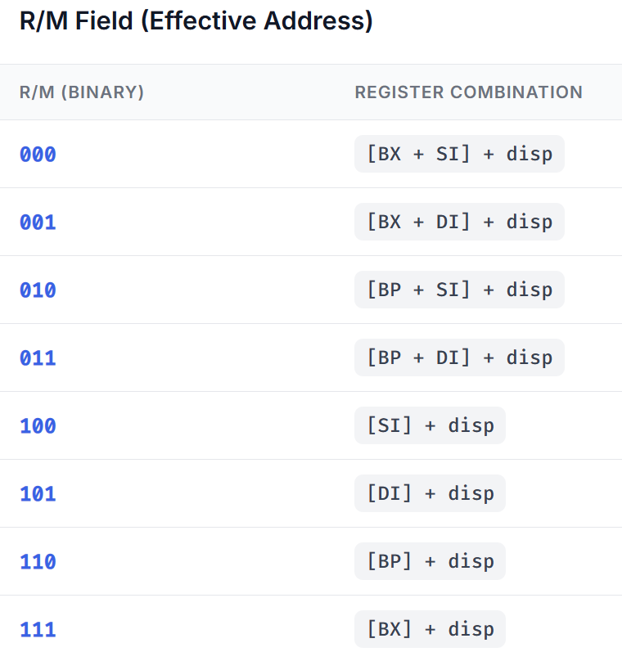

**SINGLE BYTE INSTRUCTIONS**

The simplest type of instruction is one with either no operand or an implied operand. Such instructions require only the opcode field, the value of which is predetermined by the processor's instruction set.

Table below lists a few common single-byte instructions. It might appear that the INC DX instruction slipped into the table by mistake, but the designers of the instruction set decided to supply unique opcodes for certain commonly used instructions. As a consequence, register increments are optimized for code size and execution speed.

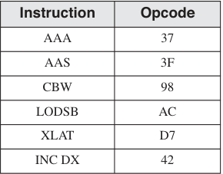

The table of single-byte instructions that you provided lists the following instructions:

* • **• AAA:** ASCII adjust for addition
* • **• AAS:** ASCII adjust for subtraction
* • **• CBW:** Convert byte to word
* • **• LODSB:** Load byte from string
* • **• XLAT:** Translate
* • **• INC DX:** Increment DX

The **AAA and AAS instructions** are used to adjust the carry flag after performing addition or subtraction operations on ASCII characters.

The **CBW instruction** converts a byte to a word by filling the upper 8 bits of the word with the sign bit of the byte.

The **LODSB instruction** loads a byte from the current position in the string pointer (SI).

The **XLAT instruction** translates a byte using the ASCII translation table in memory.

The **INC DX instruction** increments the DX register by one.

The **INC DX instruction** is included in the table of single-byte instructions because it is a commonly used instruction that is optimized for code size and execution speed.

The designers of the instruction set decided to supply unique opcodes for certain commonly used instructions, such as INC DX, in order to improve the performance of programs that use these instructions frequently.

Here is an example of how the INC DX instruction can be used:



This code will increment the DX register by one, so the value of DX will be 11 after the code is executed.

Single-byte instructions are the simplest type of instruction, but they can be used to perform a variety of operations. By understanding how to use single-byte instructions, you can write efficient and effective assembly language code.

**MOV IMMEDIATE TO REGISTER**

The passage you sent describes how to encode MOV instructions that move immediate values to registers in x86 assembly language.

The encoding format for a MOV instruction that moves an immediate word into a register is:

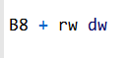

where:

**B8** is the opcode for moving an immediate value to a register.

**rw** is the register code for the destination register.

**dw** is the immediate word operand, low byte first.

To encode a MOV immediate instruction, you must first determine the register code for the destination register. The register codes are listed in the following table:

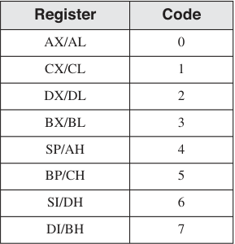

Once you have determined the register code, you can encode the MOV immediate instruction as follows:

* Add the register code to B8 to get the opcode.
* Append the immediate operand to the opcode, low byte first.

For example, the following instruction moves the immediate value 1 to the AX register:

**MOV AX, 1**

The register code for AX is 0, so the opcode for this instruction is B8 + 0 = B8.

The immediate operand is 1, so the machine code for this instruction is B8 01 00.

The machine instruction is B8 01 00 (in hexadecimal).

***Encoding Steps:***

The opcode for moving an immediate value to a 16-bit register is B8.

The register number for AX is 0, so 0 is added to B8.

The immediate operand (0001) is appended to the instruction in little-endian order (01, 00).

Another example is the following instruction, which moves the immediate value 1234h to the BX register:

**MOV BX, 1234h**

The register code for BX is 3, so the opcode for this instruction is B8 + 3 = BB.

The immediate operand bytes are 34 12, so the machine code for this instruction is BB 34 12.

The machine instruction is BB 34 12.

***Encoding Steps:***

The opcode for moving an immediate value to a 16-bit register is B8.

The register number for BX is 3, so add 3 to B8, producing opcode BB.

The immediate operand bytes are 34 12.

You can practice encoding MOV immediate instructions by hand to improve your skills.

Once you have encoded an instruction, you can check your work by inspecting the code generated by MASM in a **source listing file.**

**PUSH CX:**

The machine instruction is 51.

***Encoding Steps:***

The opcode for PUSH with a 16-bit register operand is 50.

The register number for CX is 1, so add 1 to 50, producing opcode 51.

**REGISTER MODE INSTRUCTIONS**

If you want to understand this subtopic better, check the last line of this subtopic, go to that reference.

The passage you sent describes how to encode MOV instructions that use register operands in x86 assembly language.

The encoding format for a MOV instruction that moves a value from one register to another is

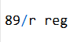

where:

* • **• 89** is the opcode for moving a value from one register to another.
* • **• /r** indicates that a Mod R/M byte follows the opcode.
* • **• reg** is the register code for the destination register.

The Mod R/M byte contains a 3-bit identifier for each register operand.

The Mod R/M byte is made up of three fields (mod, reg, and r/m). A Mod R/M value of D8, for example, contains the following fields:

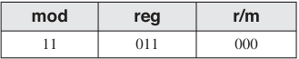

The **Mod field is 11**, indicating that the r/m field contains a register number.

The **reg field is 011**, indicating that the source operand is the BX register.

The **r/m field is 000**, indicating that the destination operand is the AX register.

Therefore, the machine code **89 D8** is for the instruction **MOV AX, BX,** which moves the value in the BX register to the AX register.

The register codes are listed in the following table:

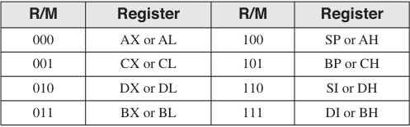

For example, the following instruction moves the value in the BX register to the AX register:

**MOV AX, BX**

The register code for BX is 3 and the register code for AX is 0, so the machine code for this instruction is 89 D8.

Another example is the following instruction, which moves the value in the CL register to the AL register:

**MOV AL, CL**

The register code for CL is 1 and the register code for AL is 0, so the machine code for this instruction is 89 C8.

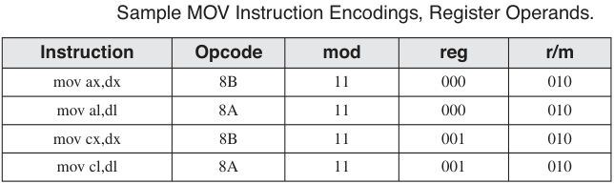

You can practice encoding MOV instructions that use register operands by hand to improve your skills. Once you have encoded an instruction, you can check your work by inspecting the code generated by MASM in a source listing file.

=================================================

***To calculate the value 89 D8 from the R/M fields, you need to follow these steps:***

Identify the addressing mode. The Mod field is 11, which indicates that the addressing mode is register direct.

Identify the source operand. The reg field is 011, which indicates that the source operand is the BX register.

Identify the destination operand. The r/m field is 000, which indicates that the destination operand is the AX register.

Encode the opcode. The opcode for the MOV instruction is 89.

Encode the Mod R/M byte. The Mod R/M byte is encoded as follows:

* **Mod field: 11 (register direct)**
* **reg field: 011 (BX register)**
* **r/m field: 000 (AX register)**

Therefore, the machine code for the instruction MOV AX, BX is 89 D8.

Here is a table that summarizes the encoding of the MOV instruction:

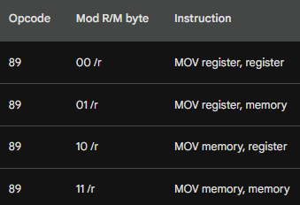

The reg field and r/m field of the Mod R/M byte identify the source and destination operands, respectively. The Mod field indicates the addressing mode for the operand.

***So, this only applies to mov instruction?***

Yes, the encoding scheme you described only applies to the MOV instruction. Other instructions may have different encoding schemes.

For example, the ADD instruction has the following encoding scheme:

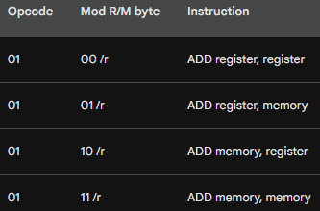

The ADD instruction is similar to the MOV instruction, but it adds the source operand to the destination operand instead of moving the source operand to the destination operand.

Different instructions have different encoding schemes because they perform different operations. The encoding scheme for each instruction is specified in the **Intel instruction set reference.**

PROCESSOR OPERAND-SIZE PREFIX

The **operand-size prefix (66h)** is used to override the default segment attribute for the instruction it modifies.

This was necessary because the 8088/8086 instruction set used almost all 256 possible opcodes to handle instructions using 8- and 16-bit operands.

When Intel introduced 32-bit processors, they needed to find a way to invent new opcodes to handle 32-bit operands, yet retain compatibility with older processors.

For programs targeting 16-bit processors, a prefix byte was added to any instruction that used 32-bit operands.

For programs targeting 32-bit processors, 32-bit operands were the default, so a prefix byte was added to any instruction using 16-bit operands. Eight-bit operands need no prefix.

***Here is an example of how to use the operand-size prefix in 16-bit mode:***

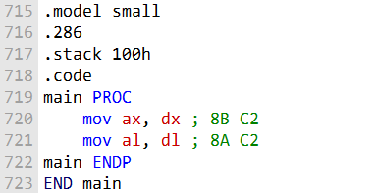

The **mov ax,dx** instruction uses 16-bit operands, so it does not need a prefix byte.

The **mov al,dl** instruction uses 8-bit operands, so it also does not need a prefix byte.

Here is an example of how to use the operand-size prefix in 32-bit mode:

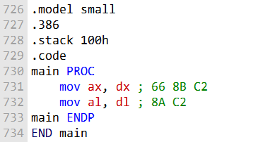

The **mov ax,dx** instruction now needs a prefix byte to indicate that it is using 16-bit operands.

The **mov al,dl** instruction still does not need a prefix byte because it is using 8-bit operands.

The operand-size prefix is a powerful tool that allows programmers to control the operand size of instructions. This can be useful for improving performance or for ensuring compatibility with older processors.

**MEMORY MODE INSTRUCTIONS**

In x86 assembly language, the Memory Mode instructions are used to access memory operands with various addressing modes.

These instructions involve loading or storing data between registers and memory locations, with different combinations of registers and memory addresses.

The Mod field in the Mod R/M byte specifies the addressing mode for the memory operand.

***Here are some key points about Mod Memory Mode instructions:***

**Mod R/M Byte:** These instructions rely on the Mod R/M byte, which is a part of the instruction encoding, to specify the addressing mode and operands. The Mod field (bits 6-7) in the Mod R/M byte defines the addressing mode.

**Mod Field:** The Mod field can take on various values:

* **00:** Register-indirect addressing mode. The memory operand is accessed via a register.
* **01:** Displacement-only addressing mode. An immediate value (displacement) is added to the base register.
* **10:** SIB (Scale-Index-Base) addressing mode. This is typically used for complex addressing calculations.
* **11:** Register mode. The operands are registers, not memory.
* **Registers and Memory:** Mod Memory Mode instructions can involve different combinations of registers and memory locations, making them versatile for reading from or writing to memory.

***Code Explanation:***

Now, let's go over the code provided in the earlier example:

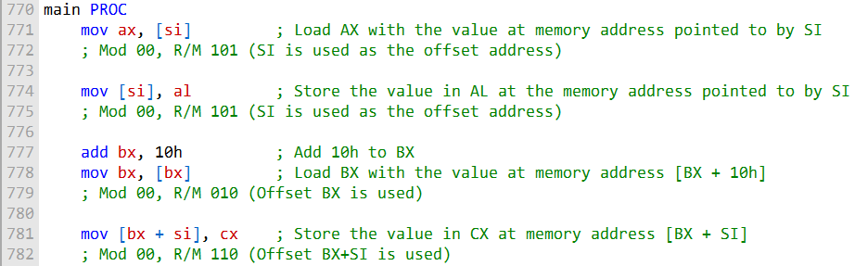

**mov ax, [si]:** This instruction loads the value from the memory address pointed to by SI into the AX register. In the Mod R/M byte, it uses Mod 00 (register-indirect addressing mode) and R/M 101 (SI is the offset address).

**mov [si], al:** This instruction stores the value in AL into the memory address pointed to by SI. It also uses Mod 00 and R/M 101, as it's effectively performing a register-indirect memory operation using SI as the offset.

**add bx, 10h:** This instruction adds 10h to the BX register.

**mov bx, [bx]:** This instruction loads the value from the memory address [BX + 10h] into the BX register. It uses Mod 00 (register-indirect addressing mode) and R/M 010 (BX is the base address with a displacement).

**mov [bx + si], cx:** This instruction stores the value in CX into the memory address [BX + SI]. It uses Mod 00 (register-indirect addressing mode) and R/M 110 (BX+SI is used as the offset).

These examples illustrate how to use Mod Memory Mode instructions to access memory operands using different addressing modes. The specific Mod R/M byte values indicate the addressing mode and operands used in each instruction.

------------------------------------------------------

**REPEATING FOR SOME ADDITIONAL INFO:**

The Mod R/M byte is a powerful tool that allows x86 assembly language programmers to specify a wide variety of memory-addressing modes.

The Mod field of the Mod R/M byte indicates the group of addressing modes, and the R/M field identifies the specific addressing mode within the group.

The following table shows the Mod R/M bytes for Mod 00:

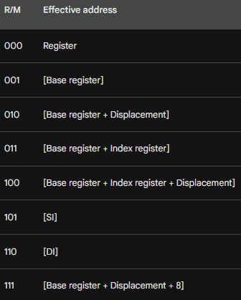

The following examples show how to use the Mod R/M byte to encode MOV instructions that use different memory-addressing modes:

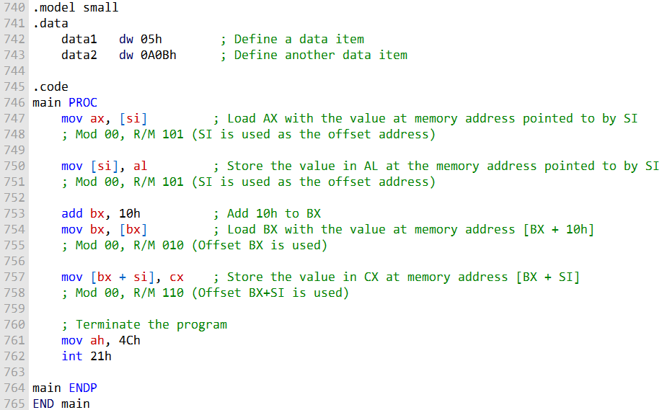

**mov ax, [si]:**

This instruction loads the value from the memory address pointed to by SI into the AX register.

Mod 00 indicates register-indirect addressing mode, and R/M 101 signifies SI as the offset address.

The value at memory address [SI] is read into AX.

**mov [si], al:**

This instruction stores the value in AL into the memory address pointed to by SI.

It uses Mod 00 (register-indirect addressing mode) and R/M 101 (SI is the offset address).

The content of AL is written to the memory location pointed to by SI.

**add bx, 10h:**

BX is loaded with the immediate value 10h.

The add instruction uses an immediate value to add 10h to the value in BX.

**mov bx, [bx]:**

This instruction loads the value from the memory address [BX + 10h] into the BX register.

Mod 00 signifies register-indirect addressing, and R/M 010 indicates the use of BX as the base address with a displacement of 10h.

BX now contains the value from memory address [BX + 10h].

**mov [bx + si], cx:**

This instruction stores the value in CX into the memory address [BX + SI].

Mod 00 indicates register-indirect addressing, and R/M 110 implies that both BX and SI are used as offsets.

The content of CX is written to the memory location at the address [BX + SI].

These examples illustrate how the Mod Memory Mode instructions enable the movement of data between registers and memory locations using different addressing modes.

**The Mod R/M byte**, as indicated in the comments, is key in specifying the addressing mode and operands for each instruction.

***Use these tables as references when hand-assembling MOV instructions. (For more details, refer to the Intel manuals.)***

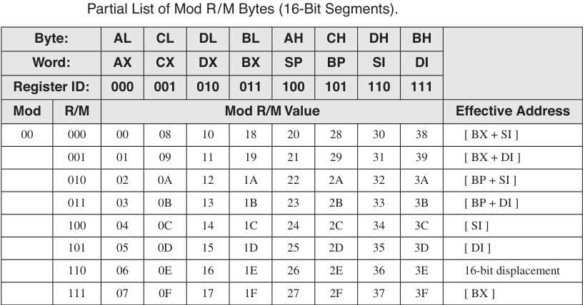

Table 2:

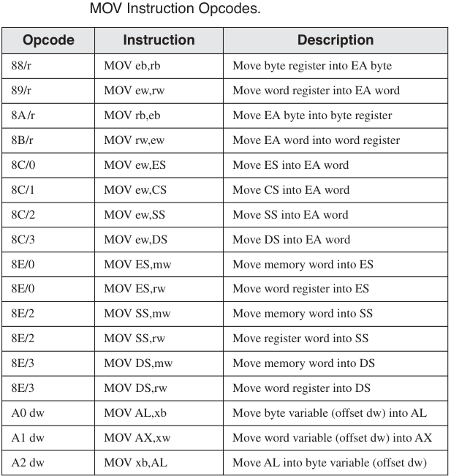

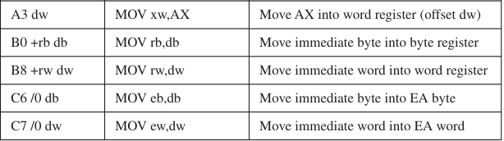

Table 3:

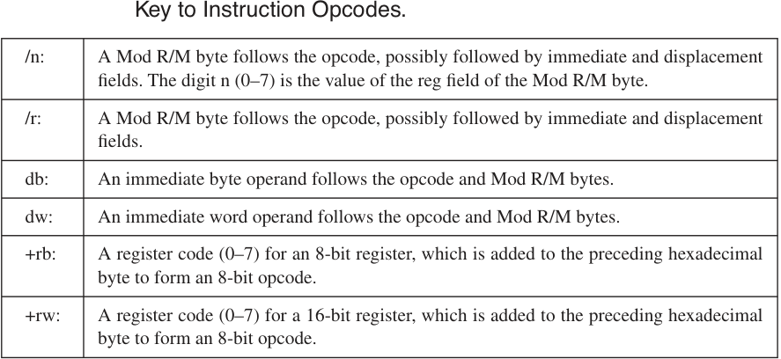

Table 4:

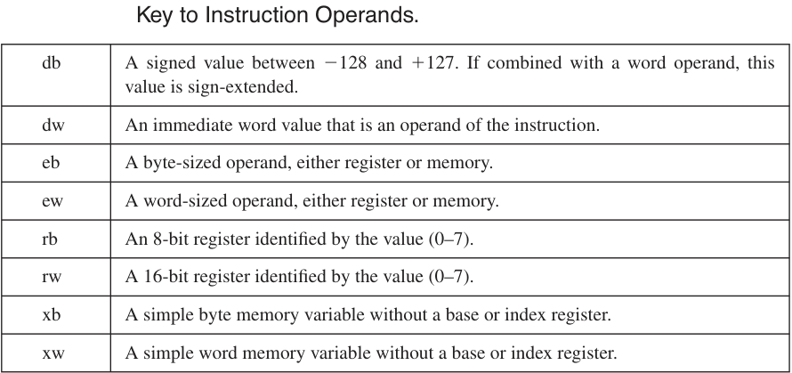

Table 12-28 contains a few additional examples of MOV instructions that you can assemble by hand and compare to the machine code shown in the table. We assume that myWord begins at offset 0102h.

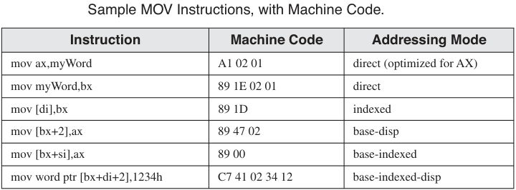

**QUESTIONS**

These questions are already answered, so just read:

**Provide the opcodes for the following MOV instructions**.

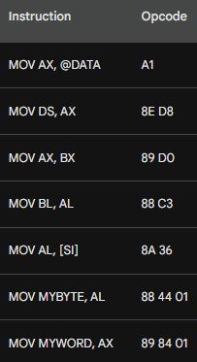

**Mod R/M bytes for MOV instructions**:

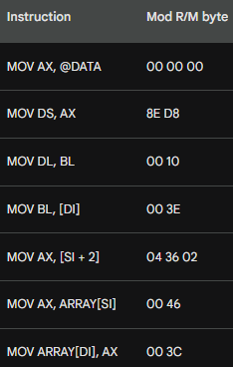

**Explanation**

The Mod R/M byte is a complex topic, but it is essential to understand how to use it in order to write efficient and effective x86 assembly language code. The following is a brief explanation of how to calculate the Mod R/M byte for each of the MOV instructions in the question:

**MOV AX, @DATA**

The @DATA operand is a symbolic address that represents the global variable DATA. The Mod R/M byte for this instruction is 00 00 00. This is because the DATA operand is a 32-bit absolute address, and the Mod R/M byte for 32-bit absolute addresses is 00 00 00.

**MOV DS, AX**

The DS register is a segment register that stores the base address of the data segment. The Mod R/M byte for this instruction is 8E D8. This is because the DS register is a special register, and the Mod R/M byte for special registers is 8E. The D8 in the Mod R/M byte indicates that the destination operand is the DS register.

**MOV AX, BX**

The AX and BX registers are general-purpose registers. The Mod R/M byte for this instruction is 00 10. This is because the BX register is register number 3, and the Mod R/M byte for register-to-register moves is 00. The 10 in the Mod R/M byte indicates that the source operand is the BX register.

**MOV BL, AL**

The BL and AL registers are general-purpose registers. The Mod R/M byte for this instruction is 00 10. This is because the AL register is register number 0, and the Mod R/M byte for register-to-register moves is 00. The 10 in the Mod R/M byte indicates that the source operand is the AL register.

**MOV AL, [SI]**

The AL register is a general-purpose register, and the [SI] operand is a memory operand. The Mod R/M byte for this instruction is 00 36. This is because the SI register is register number 6, and the Mod R/M byte for memory operands is 00. The 36 in the Mod R/M byte indicates that the base register is the SI register.

**MOV MYBYTE, AL**

The MYBYTE operand is a global variable, and the AL register is a general-purpose register. The Mod R/M byte for this instruction is 88 44 01. This is because the MYBYTE operand is a memory operand, and the Mod R/M byte for memory operands is 00. The 44 in the Mod R/M byte indicates that the destination operand is the MYBYTE operand. The 01 in the Mod R/M byte indicates that the destination operand is a byte.

**MOV MYWORD, AX**

The MYWORD operand is a global variable, and the AX register is a general-purpose register. The Mod R/M byte for this instruction is 89 84 01. This is because the MYWORD operand is a memory operand, and the Mod

WHY I SKIPPED BIOS LEVEL PROGRAMMING AND THE REST OF THE BOOK

This is the book!

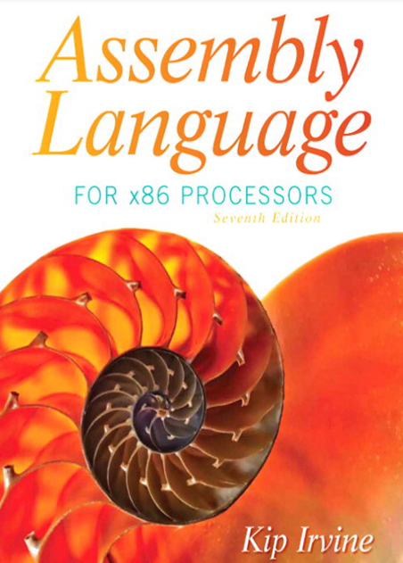

**Reasons why did I decide to skip BIOS level programming?**

* Not just BIOS level programming, but BIOS Level programming in ASSEMBLY. 💀💀That's a cocktail for death!
* I heard BIOS level programming is like trying to read hieroglyphs from an ancient computer tomb. I'll stick to modern code, no thank you.
* My computer programming philosophy: "No BIOS level, no problem!" 🚀

The rest of the topics are super advanced and I haven't really got a grasp of assembly to a level that I can deal with the following topics that remain:

**Assembly with C/C++:** I will use this book later on in life ...😄

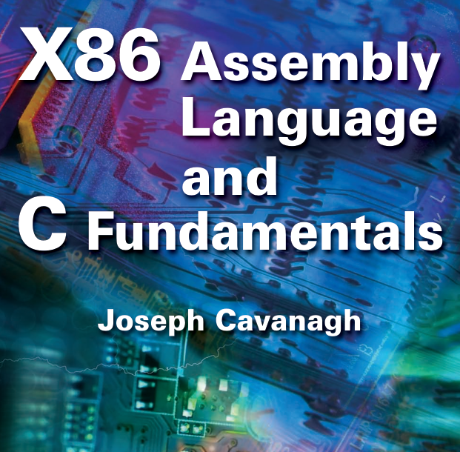

16-bit MS-DOS programming, I don't think I need that topic right now... or even in the future. It's a topic to learn for fun maybe...

[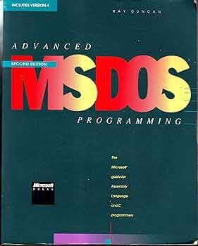](https://m.media-amazon.com/images/I/91EjsPJd-QL._AC_UF350,350_QL50_.jpg)

Disk fundamentals, I will cover that topic when I learn about operating systems storage management, using this book...



**What about MS-DOS??**

* Coz Advanced MS-DOS programmers never get lost; they just change directories! Getting lost is a necessity in life for me🗿
* Why did the advanced MS-DOS programmer bring a ladder to work? To reach the higher memory!
* Advanced MS-DOS programmers don't play hide and seek; they play "dir and find"!
* Why did the programmer use MS-DOS for his love letter? Because he wanted it to be "SYS-tematically" romantic!
* Advanced MS-DOS programmers never argue; they just "batch" their differences! patch ....💀
* MS-DOS programmers tell the best bedtime stories: "Once upon a time in a directory far, far away..."

=========================================

Greetings, Future Code Conjurers,

As I prepare to take my leave, let's reminisce about the wild ride we've had in the enchanting realm of assembly programming and operating systems. It's been a journey filled with more 0s and 1s than a binary-themed disco party, but we've managed to decode the secrets of this digital universe. 🕺💃

Within my treasure chest of meticulously updated notes and code, updated @ 2023, you'll find the keys to the kingdom of coding. It's like having a GPS for the labyrinth of algorithms and a magic wand to summon those elusive syscalls. 🪄🌐

Now, as you venture into the unpredictable landscape of real-world programming, remember that unlike the sterile environment of your IDE, reality is like a zoo. It's got bugs of all shapes and sizes, crashes that pop up like surprise parties, and sometimes, even blue screens, which are like the ultimate "You shall not pass" barriers. 🪦🪦

But fear not! With this repository of knowledge, you'll wield debugging powers that even Thor's hammer would envy. 💪🔨 And should you ever feel stuck, just remember: Ctrl + Z is your magic "Undo" spell, and Google is your friendly wizard mentor.

As you continue this epic adventure, may your code compile smoother than butter on a hot pancake, and may your systems run as smoothly as a well-oiled robot doing the moonwalk. 🤖🥞🌛

Now, as I make my exit, I can't help but grin at the thought of all the fantastic and, dare I say, "punny" code you'll create. Your journey is just beginning, and the tech universe is your playground. So go forth and code like it's the last line of defense against a robot uprising! 🌍🦾

Farewell, my fellow jesters of Java, sorcerers of C, and assembly alchemists. The tech world is your oyster; go forth and code like a wizard casting spells.

My fellow wizards and tech explorers, until we meet again in the binary dreamscape of ones and zeros, keep smiling, keep coding, and may the tech odds be ever in your favor. 😄👨‍💻👩‍💻🚀

CRUCIAL!! YOU WILL ALWAYS FIND THIS EVERYWHERE… (CLOSING CHAPTER)

* **BYTE (8 bits)**: Short form - **B**
* **SBYTE (8 bits, signed)**: Short form - **SB**
* **WORD (16 bits)**: Short form - **W**
* **SWORD (16 bits, signed)**: Short form - **SW**
* **DWORD (32 bits)**: Short form - **D**
* **SDWORD (32 bits, signed)**: Short form - **SD**
* **FWORD (48 bits)**: Short form - **FW**
* **QWORD (64 bits)**: Short form - **Q**
* **TBYTE (80 bits)**: Short form - **T**
* **REAL4 (32-bit floating-point)**: Short form - **F**
* **REAL8 (64-bit floating-point)**: Short form - **FF**
* **REAL10 (80-bit floating-point)**: Short form - **FT**

--------------------------------------------------------

A data definition statement in assembly language is used to reserve memory for a variable and to specify its data type. The general syntax for a data definition statement is as follows:

**[label] directive value**

Where:

* **label** is an optional name for the variable.
* **directive** is the data type of the variable.
* **value** is the initial value of the variable.

For example, the following data definition statement reserves 4 bytes of memory for a variable named count and initializes it to the value 12345:

**count DWORD 12345**

**int count = 12345;**

So, **label is variable, directive is the datatype, and value is the value.**

The following are some other examples of data definition statements in assembly language:

**message DB "Hello, world!"**

**age BYTE 25**

**salary SDWORD 100000**

----------------------------------------------------

The **DUP operator takes two arguments: a count and a value.** The count is an integer expression that specifies the number of times to duplicate the value.